Tobacco Tax Section

Uniformity Guide

FTA Tobacco Tax Section Regions

Central Western
Illinois Alaska
Indiana Arizona
Iowa California
Kansas Colorado
Michigan Hawaii
Minnesota Idaho
Missouri Montana
Nebraska Nevada
North Dakota New Mexico
Ohio Oregon
Oklahoma Texas
South Dakota Utah
Wisconsin Washington
Wyoming

Northeast Southern
Connecticut Alabama
Delaware Arkansas
District of Columbia Florida
Maine Georgia
Maryland Kentucky
Massachusetts Louisiana
New Hampshire Mississippi
New Jersey North Carolina
New York City Puerto Rico
New York State South Carolina
Pennsylvania Tennessee
Rhode Island West Virginia
Vermont
Virginia

Benefits of the FTA Tobacco Tax Section Activities

The FTA Tobacco Tax Section, with the help of FTA staff and the Uniformity Committee, will develop and foster a unique and effective partnership between industry and state, federal, and foreign governments regarding tobacco tax administration and enforcement. The result of this partnership should be an international network of information established that covers most everything related to tobacco taxation. This information will be made available to the states through FTA Tobacco Tax Section regional, national, and Uniformity Committee meetings, Tax Exchange, the list serve, and the FTA Web site found at www.taxadmin.org. Whenever possible, information will contain current and historical cigarette and tobacco tax data that facilitates statistical analysis and research on legal, communications, enforcement, and technology issues.

The overall benefits for states participating in FTA Tobacco Tax Section projects and utilizing its resources is reduced tax evasion, improved compliance, minimized administrative costs, increased training for audit and enforcement staff, and easy access to quality information. The FTA Tobacco Tax Section won’t dictate procedures for states to follow, but rather will provide guidance for states to use at their discretion when it comes to cigarette and tobacco tax enforcement and administration.

An environment of open communication and cooperation exists among industry and all levels of government. This reduces costs for all partners, minimizes the burden on the cigarette and tobacco industry, controls administrative costs, and fosters a combined effort to control evasion and level the playing field in the cigarette and tobacco arena.

The Uniformity Committee

Mission Statement

Provide an opportunity for government and industry to partner for the efficient and effective reporting and remittance of tobacco taxes, to minimize tobacco tax evasion, and to act as an information resource to stakeholders.

Goals

1. Implement all aspects of the 10-Point Plan.

2. Foster communication between and among levels of government, industry, and related associations and interest groups and their representatives.

3. Encourage coordination of efforts among stakeholders in audit and enforcement.

4. Encourage sharing of information among enforcement, revenue, attorneys general and federal agencies in areas related to tobacco and tobacco revenue.

5. Educate the tobacco community in areas of audit and enforcement techniques, reporting requirements, and how to identify actual and potential evasion schemes.

6. Encourage active participation by stakeholders in Uniformity meetings and inform stakeholders on how the goals of Uniformity are designed to work for all members of the tobacco community.

7. Encourage uniformity in reporting definitions and forms.

8. Prepare for change by staying informed on emerging topics and trends by assuring personnel are fully informed to allow for ease of transition and by being open to new ideas and methods for revenue reporting and remittance.

The 10-Point Plan

- Adopt/implement uniform reporting guidelines for all states.

- Adopt/implement uniform definitions and forms.

- Incorporate the Federal Employer Identification number (FEIN), Social Security number (SSN), or Canadian Federal Business number (BN) as a reference for reporting information between jurisdictions.

- Promote licensing of all persons that handle tobacco.

- Adopt/implement procedures to achieve total accountability of tobacco.

- Utilize uniform electronic reporting standards for tobacco information.

- Promote workshops for audit and investigative techniques to identify tax evasion schemes and ensure regulatory compliance.

- Review and establish Memorandums of Understanding to promote and share information that will facilitate tobacco tax compliance.

- Utilize third party information on the movement of tobacco.

- Encourage states to establish and adequately maintain a compliance staff dedicated to tobacco tax enforcement.
Organization and Responsibility

The Federation of Tax Administrators Tobacco Tax Section Uniformity Committee has four subcommittees. Each committee is assigned areas of responsibility from the 10-Point Plan.

Communication and Legislation
(Points #1, 4, 8 & 10)

- Promote uniform filing, licensing and exchange agreements with states through the use of common definitions, guidelines and forms
- Review legislation affecting the tobacco industry
- Publications:
Uniformity Guide
Uniformity Brochure

Compliance
(Points #5, 7 & 9)

Educate and advise stakeholders by:
- Publicizing case studies and best practices
- Acting as a liaison to law enforcement
- Involving stakeholders at all levels
- Establishing a clearinghouse of effective tools to combat tobacco tax evasion
- Encouraging states to educate staff on accounting and distribution processes

Forms
(Points #2 & 3)

Monitor the use of approved uniform forms, sub-schedules, and evaluate the purpose and need for new forms as they’re requested
- Definitions and terms

Technology
(Point #6)

- Develop and maintain a standard electronic filing and remittance process
- Facilitate and encourage the implementation of the standard electronic filing and remittance process
- Educate non-technical staff on how to use the standard electronic filing and remittance process
- Work with TIGERS to establish uniform standards for electronic reporting.

Table of Contents
Introduction 8
Adopt/implement uniform reporting guidelines 9
Adopt/implement uniform definitions and forms 10
Procedures for Adding, Deleting, or Modifying a Definition 10
Acronyms 11
Uniform Forms 19
PA-1: State CIGARETTE PACT Act Report 20
PA-2: State TOBACCO PACT Act Report 22
Uniform Cigarette Inventory Schedule 24
Uniform Stamp Schedule 26
Uniform Cigarette Transaction Schedule 28
Uniform Tobacco Transaction Schedule 30
Cigarette Schedules of Receipts and Disbursements 32
Tobacco Schedules of Receipts and Disbursements 36
Uniform Purchase-Based Tobacco Cover Page 40
Uniform Sales-Based Tobacco Cover Page 44
Electronic Filing Receipt Acknowledgement 47
Uniform Incident Forms 48
RFP Checklist for stamps 54
RFP Checklist for e-filing system 55
White Papers 57
Modified Risk Tobacco Products 58
Taxation of E‐cigarettes and Their Components 60
Incorporate Identification Numbers 66
Promote licensing of all persons 67
Adopt/implement procedures to achieve total accountability 68
Utilize uniform electronic reporting standards 69
Promote audit and investigation workshops to identify tax evasion 70
Review and establish MOUs to promote and share information 71
Utilize third party information 73
Encourage States to establish a tobacco compliance staff 74

Introduction

The Importance of Uniformity

Cigarette and tobacco taxes are a vital part of every state’s revenue base, providing funding for a wide variety of programs. Uniformity makes it easier to ensure that each state is getting the fairest share of the revenue it deserves.

Evasion and Lack of Uniformity

Although there are many similarities, each state has its own unique set of tax laws, tax rates, reporting forms, definitions, exemptions, and compliance methods. These differences can create problems in tax administration, regulation of cigarette and tobacco movement, enforcement efforts, exchange of information among state revenue agencies, and provide incentives for some to evade state cigarette and tobacco taxes.

Some states have traditionally ignored compliance efforts for cigarette and tobacco taxes. Until recently, cigarette and tobacco taxes were considered to be a minor part of the total state revenue, and it was commonly thought there were no real evasion issues. However, as state legislatures struggle to maintain government services with increasingly tighter budgets, cigarette and tobacco taxes are receiving more attention. State and federal tobacco tax rates have steadily increased over the past ten years, providing a greater incentive for tax evaders to circumvent vital revenues and, at the same time, increase the tax burden on legitimate businesses.

Why States Adopt the Uniformity Recommendations

Uniformity offers the best method for reducing inefficiencies in state cigarette and tobacco tax administration and combating tax evasion.

Adopt/implement uniform reporting guidelines

The Uniformity Committee assists in establishing uniform reporting guidelines among the states for exchanging information on the movement of cigarette and tobacco products. Uniform reporting guidelines are a critical tool since each state has its own unique set of tax laws, tax rates, reporting forms, definitions, exemptions, and compliance methods.

Purpose

Uniform forms make it easier for industry to comply with filing requirements. Taxpayers filing in more than one state or taxing jurisdiction can find it much easier to comply by using uniform forms.

Uniform forms can be used for states to share information with other states.

Adopt/implement uniform definitions and forms

The 10-Point Plan emphasizes the need to use uniform definitions of terms and standard forms by state taxing authorities and the cigarette and tobacco industry to promote clear understanding and facilitate improved communications.

Purpose - Definitions

To develop clear and concise definitions dealing with cigarette or tobacco distribution and taxation that can be used and understood by federal and state governments as well as industry representatives. This allows the advancement of uniformity through a clear understanding of universally used terms.

All definitions presented to the Uniformity Committee for approval, and ultimately to the Federation of Tax Administrators for adoption, are presented as model definitions for use by state taxing authorities.

These definitions are not in any way intended to be construed as legal, legislative, or technical definitions and may be modified at the discretion of the user.

Procedures for Adding, Deleting, or Modifying a Definition

Action By | Step | Action
Anyone | 1 | Submit in writing term to be defined, deleted, or modified to the Chairperson of the FTA Tobacco Tax Section Uniformity Committee, along with an explanation of why the term should be defined, deleted, or modified and provide a suggested definition, if available. The name of a contact person should be included with submission.
Uniformity  Chairperson | 2 | Receives the requested action and logs the request.  If the request is to define a term, the Chairperson will verify that no definition exists.  Copies the request and forwards to the Forms Subcommittee.
Forms Subcommittee | 3 | Reviews the request and assembles suggestions for discussion with the requestor(s)/representative.
Forms Subcommittee | 4 | Proposes definition, modification, or deletion of term.
Uniformity  Chairperson | 5 | Places the proposed definition, modification, or deletion on the agenda of the next Uniformity Committee meeting for formal adoption.
Uniformity  Committee | 6 | Discuss the requested action and accept or reject the definition as added, deleted, or modified.
Uniformity  Chairperson | 7 | If accepted - send the accepted change to the Federation of Tax Administrators (Tobacco Tax Coordinator) to prepare a resolution  and update the FTA definition list.  If rejected - the proposed definition, modification, or deletion is returned to the original requestor along with an explanation of the rejection.

Acronyms

ATF Bureau of Alcohol, Tobacco, Firearms, and Explosives
BOL Bill of Lading
CCTA Contraband Cigarettes Trafficking Act
FDA Food and Drug Administration
FET Federal Excise Tax
LET Local Excise Tax
MSA Master Settlement Agreement
NPM Non-Participating Manufacturer (MSA related)
OPM Original Participating Manufacturer (MSA related)
OTP Other Tobacco Products (other than cigarettes)
PACT Prevent All Cigarette Trafficking Act
RYO Roll-Your-Own Tobacco
SET State Excise Tax
SPM Subsequent Participating Manufacturer
TTB Alcohol and Tobacco Tax and Trade Bureau

Definitions

These definitions are terms generally used by tobacco tax administrators and industry, and are meant to inform users, promote understanding, and to facilitate discussion between the participants. The definitions are not intended to be legal or to include all-encompassing meanings of the defined terms.

At the end of a definition if you see the term “Refer also to...” there is another word or term that may be directly related or has basically the same definition.

At the end of a definition if you see the term “See also…” there is another word or term that may be confused with the current definition, but the definitions and meaning do differ.

Acquisition Date – The date a taxable product was received at a physical facility after a change in physical possession of taxable product.

Additive – Any substance the intended use of which results or may reasonably be expected to result, directly or indirectly, in its becoming a component or otherwise affecting the characteristic of any tobacco product (including any substances intended for use as a flavoring or coloring or in producing, manufacturing, packing, processing, preparing, treating, packaging, transporting, or holding), except that such term does not include tobacco or a pesticide chemical residue in or on raw tobacco or a pesticide chemical.

Adjustments and/or Tax Credits – Adjustments that can only be shown and deducted as a monetary adjustment because of their nature, other than physical inventory adjustments (i.e. bad debt allowances). (See also “Book Adjustment/Physical Variance”.)

Agent – A person normally licensed or registered and designated through legislation as the agent to collect and remit tax on behalf of a taxing jurisdiction. Agents may be referred to as a licensed wholesaler, licensed manufacturer, licensed distributor, supplier, dealer, exporter, importer, and/or sub-Jobber. Agents typically file tax or information returns.

ATF – The Bureau of Alcohol, Tobacco, Firearms and Explosives which is a United States Department of Justice agency. The ATF among other things conducts criminal investigations involving illegal cigarette trafficking which can violate the CCTA, PACT Act, and other money laundering violations involving untaxed cigarettes and tobacco products.

Basic Cost – The invoice cost of a taxable product to a wholesaler or a retailer exclusive of any discounts, rebates, or off-invoice allowances. (May also be referred to as “invoice cost”.)

Beginning Inventory – Physical Inventory of taxable product at the beginning of a reporting period. (Also referred to as “Opening Untaxed Inventory”.)

Bill of Lading (BOL) – A document issued by a common carrier representing the delivery and physical transfer of a taxable product from a consignor to a consignee. A bill of lading defines the contract for transportation between the shipper and carrier and also serves as a document of title and a receipt for the goods. (See also “Freight Bill”.)

Book Adjustment/Physical Variance – An adjustment to books, records, or computerized inventories itemizing changes in physical inventory volume, of a taxable product, with no physical movement of the product. (See also “Adjustments and/or Tax Credits”.)

Brand Family – A type of cigarette or tobacco product distinguished by unique attributes. These unique attributes can be the tobacco used, tar and nicotine content, flavoring used, size, filtration, packaging, logo, registered trademark, brand name, identifiable pattern of colors, or any combination of such attributes. Examples of brands may include Marlboro, Camel, Kool, Salem, Winston, etc.

Brand Style – A type of cigarette distinguished by unique attributes within a brand family. These unique attributes can be the tobacco used, tar and nicotine content, flavoring used, size of the cigarette, filtration on the cigarette or packaging. Examples of descriptors of styles include but are not limited to “menthol”, “lights”, “kings”, and “100s”.

Carton – A container used to contain and convey multiple “original packages” available for sale to consumers.

Cigar – These definitions are taken from the Combined Federal Regulation (27 CFR parts 40.11). It mirrors the definitions in the law (26 USC 5701)
Cigar. Any roll of tobacco wrapped in leaf tobacco or in any substance containing tobacco (other than any roll of tobacco which is a cigarette within the meaning of paragraph (2) of the definition for cigarette).
Large cigars. Cigars weighing more than three pounds per thousand.
Small cigars. Cigars weighing not more than three pounds per thousand.
Cigarette – Generally recognized as any roll for smoking made wholly or in part of tobacco irrespective of size or shape and whether or not such tobacco is flavored, adulterated or mixed with any other ingredient, and the wrapper or cover of which is made of paper or any other substance or material except tobacco.

Some states may also include in their definitions:
- product that includes tobacco, in any form, that is functional in the product, which, because of its appearance, the type of tobacco used in the filler, or its packaging and labeling, is likely to be offered to, or purchased by, consumers as a cigarette or as roll-your-own tobacco.
- little cigars
- rolling tubes/papers
- product that meets the definition of the term “cigarette” in section 3(1) of the Federal Cigarette Labeling and Advertising Act

Cigarette Tobacco – any product that consists of loose tobacco that is intended for use by consumers in a cigarette. (Refer also to “Roll-Your-Own Tobacco”.)

Closing (or Ending) Inventory – The physical Inventory of taxable product at the end of a reporting period. Inventory can either be considered “unverified” or “verified” depending on whether or not a state agency verified the physical inventory.

Commerce – The buying and selling of taxable product, as between cities, states, tribes, or nations. Taxable product delivered out of a state by or for a seller constitutes interstate commerce. Taxable product delivered within a state by or for a seller constitutes intrastate commerce. (Refer also to “Export”.)

Compensation Allowances – Authorized commissions, discounts, or compensation provided to a distributor for acting on behalf of the state authorities in the collection of the taxes due on taxable tobacco products, e.g. allowances for affixing tax stamps or filing and or paying a tax return timely. (See also “Merchandising Allowances/Discounts”.)

Common Carrier – A person that engages in the commercial transportation of taxable products that are not owned by a person. Types of commercial common carriers may include rail, marine vessel, aircraft and truck. (Refer also to “Transport Vehicle”.)

Common Carrier BOL Number – The identification number on the Bill of Lading issued by the common carrier for transportation of taxable products. It is a receipt from the carrier for the physical transfer of taxable products. A freight bill is an invoice for the transportation provided and is based on the bill of lading and other information used to determine the rate for the transportation charges. They are sometimes combined into a "Combination bill of lading and freight bill".

Common Carrier ID – A unique identifying number assigned to a common carrier by a regulatory agency such as the U.S. Department of Transportation.

Consignee – The person to whom the taxable product is delivered by a carrier.

Consignor – The person that hires the carrier to transport the taxable product.

Consumer – A person that consumes or uses a taxable cigarette or other tobacco product.

Contraband Cigarettes – May be defined as any of the following: (1) cigarettes that do not bear the required tax stamp for the appropriate jurisdiction; or (2) cigarettes for which the required federal taxes have not been paid; or (3) cigarettes that bear a counterfeit tax stamp; or (4) any cigarettes which may not be legally possessed for resale; or (5) counterfeit cigarettes.

Counterfeit Cigarettes - (1) cigarettes that are manufactured, fabricated, assembled, processed, packaged, or labeled by any person other than the owner of the trademark rights in the cigarette brand or a person that is directly or indirectly authorized by such owner; or cigarettes imported into the United States, or otherwise distributed, in violation of any federal law; or (2) cigarettes that have false manufacturing labels.

Counterfeit Other Tobacco Products - (1) Other tobacco products that are manufactured, fabricated, assembled, processed, packaged, or labeled by any person other than the owner of the trademark rights in the tobacco product brand or a person that is directly or indirectly authorized by such owner; or tobacco products imported into the United States, or otherwise distributed, in violation of any federal law; or (2) other tobacco products that have false manufacturing labels.

Contraband Cigarettes Trafficking Act (CCTA) – A federal law dealing with trafficking of contraband cigarette and tobacco products (18 USC Chapter 114).

Credits/Refunds – Allowable reduction in tax liability based on certain criteria having been met. Credits or refunds may be issued for damaged tax stamps; tax stamps (or tax paid) on unusable or unsalable product; or stamped (or tax paid) product that was returned to a manufacturer.

Delivery – A physical transfer and/or change of legal ownership of a taxable product.

Delivery Date – Refer also to “Acquisition Date”.

Destination Jurisdiction - Any state, territory, foreign country, jurisdiction, territory, or sovereign nation to which any taxable cigarettes or other tobacco products are directed for delivery into any storage facility, receptacle, container, or any type of transportation equipment for purpose of resale or use.

Distributor - A person who acquires and distributes cigarettes or other tobacco products, whether domestic or imported, from the original manufacturer or any other person for the purpose of reselling that product. (Refer also to “Wholesaler”.)

Drop Shipment – Any delivery of a taxable product received by a consignee when payment for the taxable product is made to the shipper or seller by or through a person other than the consignee.

Electronic Cigarette (aka E-Cigarette) – A handheld battery-powered vaporizer that stimulates smoking but without tobacco combustion.

E-liquids – A type of ENDS product generally referring to liquid nicotine and nicotine-containing e-liquids.

Electronic Nicotine Delivery Systems (ENDS) – Noncombustible tobacco products. Includes devices, components, and/or parts that deliver aerosolized e-liquid when inhaled. Examples include vape or vape pens, personal vaporizers, electronic cigarettes, cigalikes, e-pens, e-hookahs, e-cigars and e-pipes.

Exempt Sales – The sale, gift, or exchange of taxable product that is not subject to cigarette and/or tobacco tax in accordance with jurisdictional legislation, regulations, or other authority.

Exempt Sales Type – Possible various types of tax-exempt sales may include:

- Export sales
- Federal government sales
- Indian sales
- Military sales
- Research sales other than for marketing purposes
- Sales between wholesalers and distributors as regulated by that jurisdiction’s legislative or regulatory body.

Export – The shipment or delivery of a taxable product to a location outside the country from which the product originated. Taxable product delivered out of a country by or for a seller constitutes exportation by the seller. (Refer also to “Commerce”.)

Exporter - Any person engaged in the practice of transferring taxable product from one country to another country.

Federal Excise Tax (FET) – An excise tax that is levied by the United States federal government.

Filtered Cigar – See “Cigar”.

Foreign Trade Zone – A U.S. Customs regulated area within which goods may be received and stored without payment of duty, tariffs, taxes etc. (May also be referred to as “Free Trade Zone”.)

Freight Bill – A freight bill is an invoice for the transportation provided and is based on the bill of lading and other information used to determine the rate for the transportation charges. They are sometimes combined into a "Combination bill of lading and freight bill". (See also “Bill of Lading (BOL)”.)

Illicit Trade - Any practice or conduct prohibited by law which relates to the production, shipment, receipt, possession, distribution, sale, or purchase of cigarettes or other tobacco products, including any practice or conduct intended to facilitate such activity.

Import – The shipment or delivery of taxable product to a location inside the country when the product originated from a location outside the country. Taxable product delivered into a country by or for the purchaser constitutes importation by the purchaser. (Refer also to “Commerce”.)

Importer - A person that causes the import of taxable products into a country from another country. (Counterpart of “Exporter”.)

Importer Number – Specific number assigned to an Importer by the Tobacco Tax Trade Bureau (TTB) for payment of federal excise tax.
Indian Tribe – an American Indian or Alaskan Native tribe, band, nation, pueblo, village, or community that the Secretary of the Interior acknowledges to exist as an Indian tribe pursuant to the Federally Recognized Indian Tribe List Act of 1994, 25 USC 479a. (See section 4(e) of the Indian Self-Determination and Education Assistance Act.)

Interstate Commerce – The shipment or delivery of taxable product to a location outside the state from which the shipment originated. Taxable product delivered out of a state by or for a seller constitutes interstate commerce. (Refer also to “Commerce”.)

Intrastate Commerce – The shipment or delivery of taxable product to a location within the state from which the shipment originated. Taxable product delivered within a state by or for a seller constitutes intrastate commerce. (Refer also to “Commerce”.)

Inventory – The taxable product that is physically stored at a location.

Inventory Adjustment – Refer also to “Book Adjustment/Physical Variance”.

Invoice – An invoice or bill is a commercial document issued by a seller to the buyer, indicating the accountable product(s), quantity(s), and agreed price(s) for products or services the seller has provided the buyer. An invoice indicates the buyer must pay the seller, according to the payment terms.

For a seller, an invoice is a sales invoice. For a buyer, an invoice is a purchase invoice. The document indicates not only the buyer and seller, but the invoice terms and the money owed or owing.

Large Cigar – See “Cigar”.

Local Excise Tax (LET) – An excise tax that is levied by a city, county, municipality, jurisdiction, borough, etc.

License (or Permit) – A legal document issued by a regulatory agency by which a person is granted authority to manufacture, import, sell, distribute or export taxable product.

Little Cigar – See “Cigar”.

Manifest - A document that lists several shipments contained within a trailer for delivery by a common carrier.

Manufacturer – Any person who manufacturers, fabricates, assembles, processes, or labels a finished taxable product.

Master Settlement Agreement (MSA) – Signed in November of 1998, this civil settlement between participating tobacco manufacturers and participating states exempts the tobacco manufacturers from tort liability from state governments in exchange for a combination of yearly payments to the states and voluntary restrictions on advertising and marketing tobacco products.

Merchandising Allowances/Discounts – Generally any number of incentives that are offered by a manufacturer for timely payment of invoices, volume purchases, promotional purchases, etc. (Also see “Compensation Allowances”.)

Non-Participating Manufacturer (NPM) – Any tobacco product manufacturer who is not a participating manufacturer to the Master Settlement Agreement. NPMs place a MSA-specified amount of funds into a qualified escrow account for each year they sell cigarettes or cigarette equivalents into a settling state.

Original Package – Any individual packet, box, or other container used to contain and convey cigarettes or other tobacco products to the consumer. This definition of original package does not include multiple packages within a carton. (See also “Carton”.)

Original Participating Manufacturer (OPM) – A tobacco product manufacturer who is a signatory to the Master Settlement Agreement. Brown & Williamson Tobacco Corporation, Lorillard Tobacco Company, Philip Morris Incorporated, and R.J. Reynolds Tobacco Company and the respective successors of each of these companies are the original signatories to the Master Settlement Agreement.

Person – Any natural individual, firm, trust, estate, partnership, association, joint stock company, joint venture, corporation, limited liability company; or a receiver, trustee, or guardian or other representative appointed by order of any court; or any city, town, county, or other political subdivision or Indian tribe. Additionally, whenever used, the term “person” as applied to partnerships and associations shall mean the partners or members thereof. As applied to a limited liability company, the term “person” shall mean the officers, member agents, or employees of the limited liability company, and as applied to corporations, the term “person” shall mean the officers, agents, or employees.

Point of Delivery – The specific address of delivery, including but not limited to customer name, street, city, state, and zip code, to which transfer of ownership and possession of taxable cigarettes and other tobacco products takes place.

Point of Taxation – The instance in the distribution of a taxable product when a tax is levied and applied as regulated by a taxing authority.

Reporting Period – For the purpose of cigarette and other tobacco products tax inventory and/or tax reporting, the reporting period is on a monthly, quarterly, or other basis as may be deemed necessary by statute or regulation.

Retail Location – Any location which may require licensing or other authorization by state or local statutes from which taxable product is sold to an end user for personal use or consumption. A retail location may include, but is not limited to, a place, store, booth, concession, truck, vehicle, or vending machine.
Retailer – Any person who operates a retail location and engages in the sale or making transfers of ownership of, or title to, taxable products to a purchaser for use or personal consumption and not for resale in any form.

Roll-Your-Own Tobacco (RYO) – Any tobacco product which, because of its appearance, type, packaging, or labeling, is suitable for use and likely to be offered to, or purchased by, consumers as tobacco for making cigarettes. (May also be referred to as “Cigarette Tobacco”.)

Sale – In addition to its ordinary meaning, any transfer, gift exchange, barter, or other disposition of a taxable product. In every case where such a taxable product is exchanged, given or otherwise disposed of, it shall be deemed to have been sold.

Sample – a tobacco product distributed at no cost for the purpose of promoting the product.

Settling State – Any state or territory that has signed the MSA. The settling states do not include Mississippi, Florida, Texas and Minnesota.

Shipping Container – The case, box, parcel, or other container in which cartons or packages of cigarettes or other tobacco products are placed for shipment or transportation from one place to another. “Shipping container” does not include a package in which retail sales of cigarettes or other tobacco products are normally made or intended to be made.
Small Cigar – See “Cigar”.

Smokeless Tobacco – Any non-combustible tobacco product that consists of cut, ground, powdered, or leaf tobacco and that is intended to be placed in the oral or nasal cavity.

State Excise Tax (SET) – An excise tax that is levied by a state.

Subsequent Participating Manufacturer (SPM) – A tobacco product manufacturer who is not one of the original participants of the Master Settlement Agreement but has since signed the agreement.

Stamp – A stamp or other indicia that is printed, manufactured, or made under the authorization of a taxing authority that is sold, issued, or circulated and used to pay cigarette or other tobacco products taxes.

Stamping Device – Machinery or hand-held device by which tax stamps are applied to a taxable product.

Sub-jobber – A person, other than a manufacturer or distributor, who is engaged in the distribution of tax-paid cigarettes and other tobacco products to retailers for resale. Sub-jobbers sell taxable products to retailers, ultimate consumers, or they operate vending machines. Sub-jobbers are a category of wholesaler or distributor but are unique in that they acquire their inventory from someone else who has paid all taxes due. Some states also include sub-jobbers in their definition of a distributor.

Taxable Product – Cigarettes and other tobacco products (OTP) that are subject to federal, state, or local excise taxes.

Tobacco Product Manufacturer – Any person, including any repacker or relabeler, who manufactures, fabricates, assembles, processes, or labels a tobacco product; or imports a finished tobacco product for sale or distribution in the United States.

Tobacco Trade Bureau (TTB) – A federal agency charged with regulating and overseeing the alcohol, tobacco, and firearm trade in the United States. The Alcohol and Tobacco Tax and Trade Bureau, shortened to Tax and Trade Bureau, or TTB, is a bureau of the United States Department of the Treasury. Some of the functions of the TTB include auditing alcohol, tobacco, firearms, and ammunition excise tax cases; ensuring fair and proper revenue collection due the federal government; conducting investigations of suspected alcohol and/or tobacco tax evasion cases; promoting voluntary compliance by monitoring the domestic tobacco trade and ensuring compliance with the tax laws relating to alcohol, tobacco and firearms.

Transporter – A person who transports taxable product from a manufacturer, importer, or storage and/or distribution facility by means of a transport truck, aircraft, railroad car, or marine vessel. (Refer also to “Common Carrier”.)

Transport Truck/Vehicle - A vehicle used to transport taxable product.

TTB Importer Permit Number – The unique number assigned by TTB to each importer.

Units Sold – The precise definition of “Units Sold” varies from state to state. It generally refers to the number of cigarettes (in many cases this includes RYO) on which a nonparticipating manufacturer must pay escrow.

U.S. Customs Entry Number - The tracking/registration number assigned by U.S. Customs which identifies the specific importer, name of the district port of entry, product description, product manufacturer information, and other pertinent information specific to entry into the United States.

Vending Machine – Any mechanical device by which taxable product is sold or dispensed in its original package. Some states consider a vending machine as a separate “retailer”.

Validated Losses – Taxable product losses which can be significantly documented including documented loss due to fire, flood, or third-party theft.

Wholesaler – Any person engaged in the business of selling cigarettes or other tobacco products to authorized, registered, and/or licensed wholesalers, distributors, or retailers for the purpose of resale.

Uniform Forms

Purpose - Forms

Uniform reports and schedules serve two purposes. First, uniform reports and schedules provide a uniform mechanism for industry and government to record cigarette and tobacco tax transactions. Second, the forms facilitate information exchange between states by ensuring each state collects similar data.

If a manufacturer uses all of the forms, that entity can account for all cigarette and tobacco transactions by reporting the same type of data in a similar format for each state’s cigarette and tobacco tax reports. Having standardized reporting provides the industry a better understanding of what is required and they will be better able to comply with each state’s requirements. States using standardized forms will more likely receive the data needed from all taxpayers in a desirable format.

The following pages contain forms that have been approved by the FTA Tobacco Section Uniformity Committee for use by all states and industry.
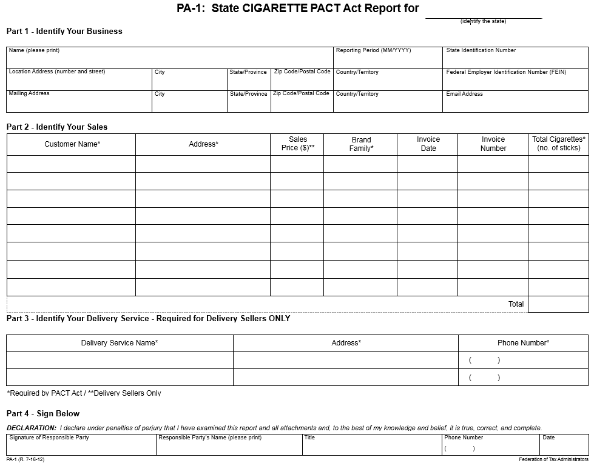

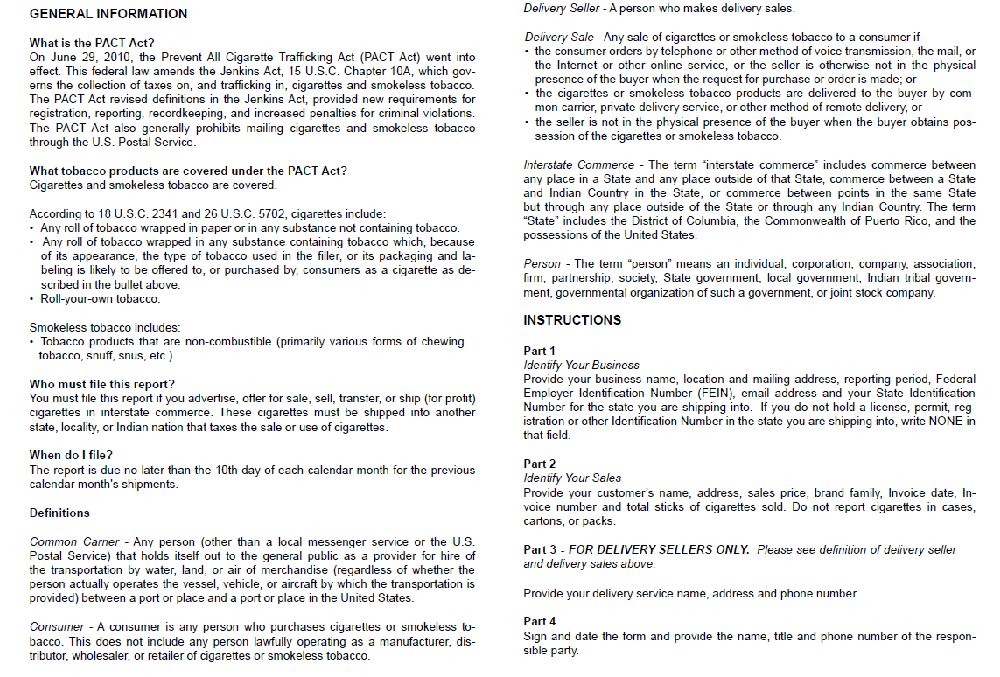

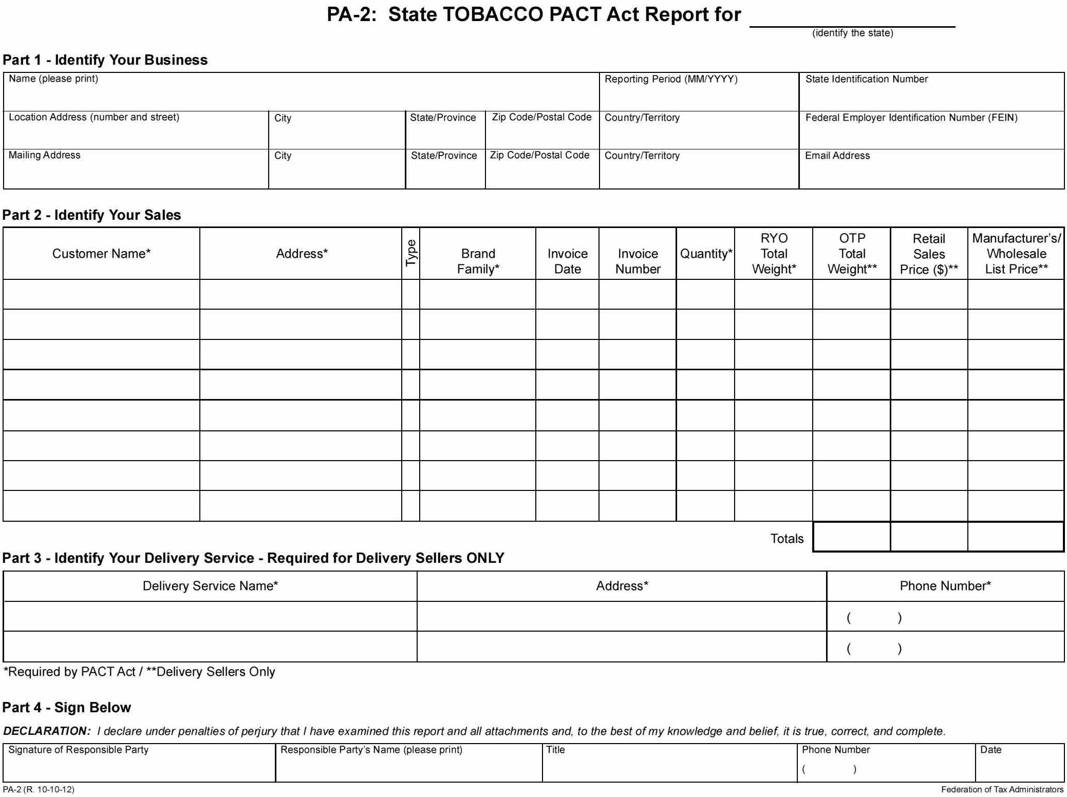

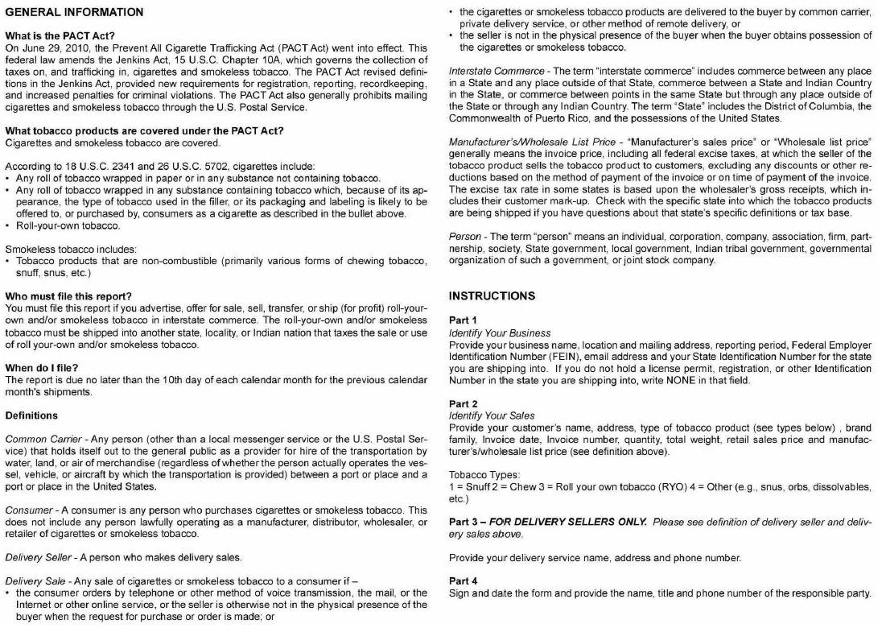
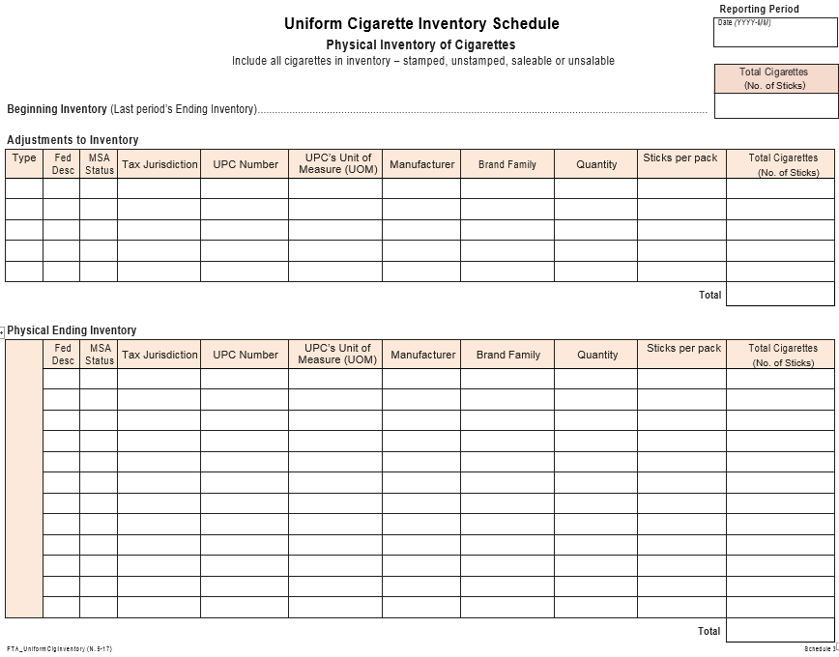
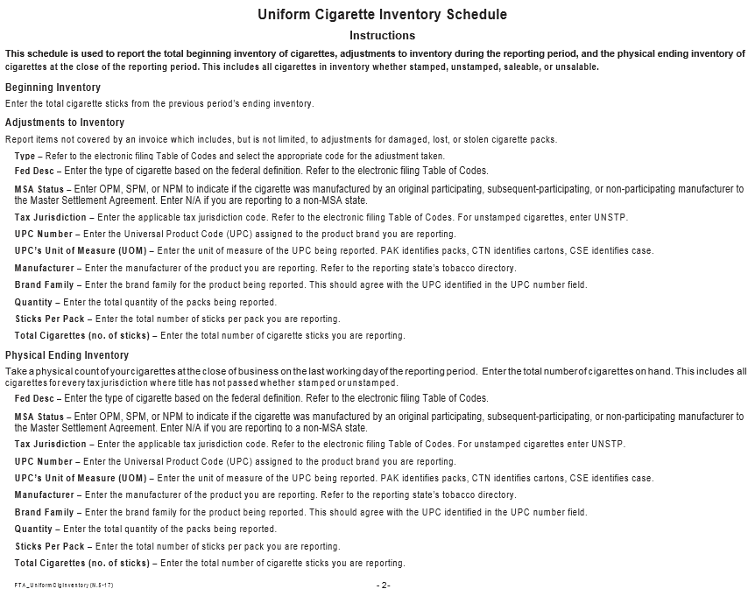
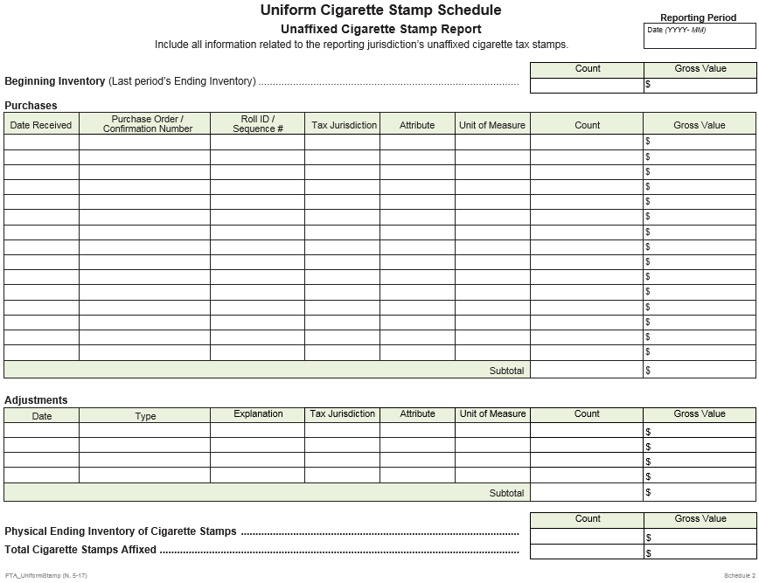
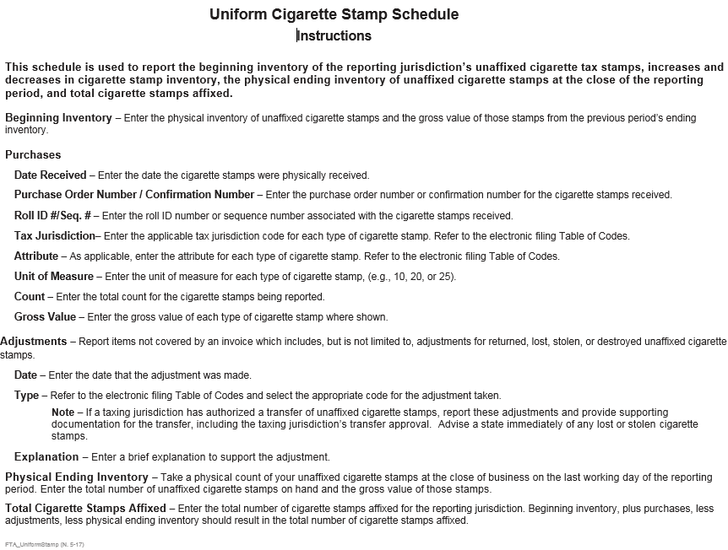
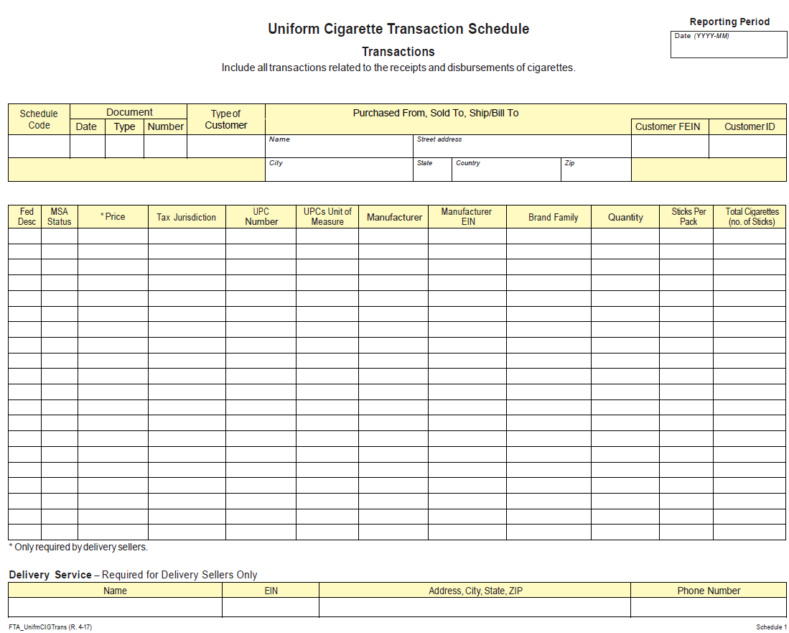
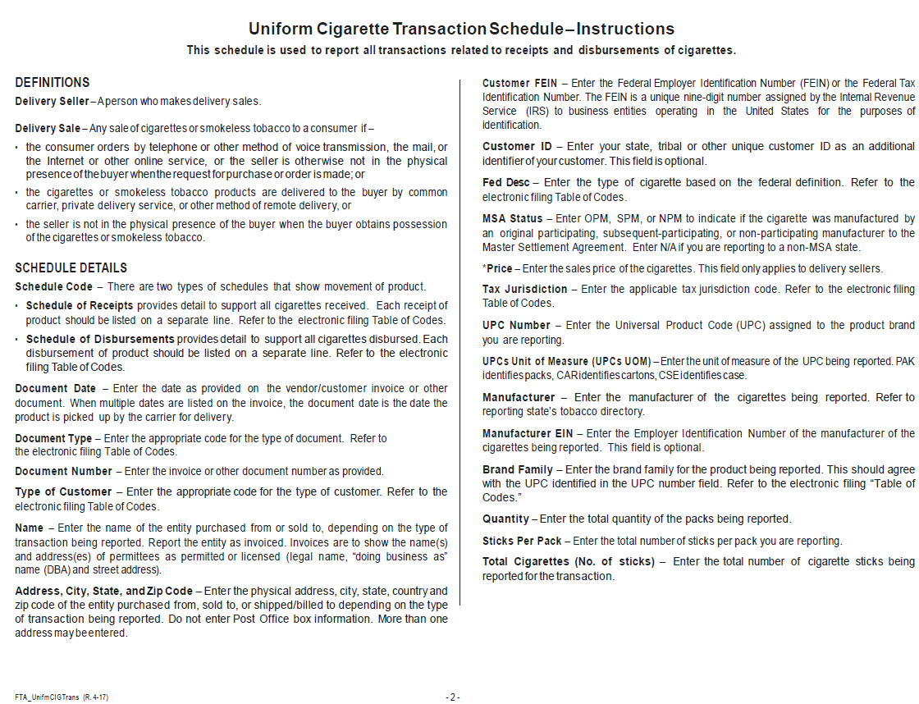
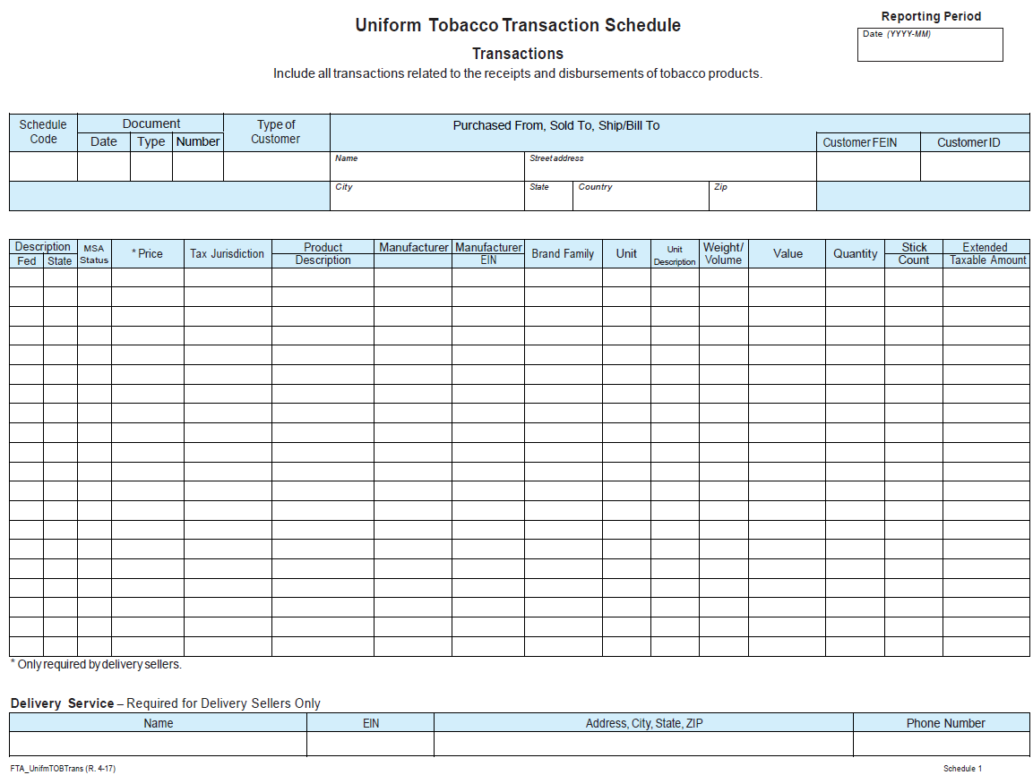
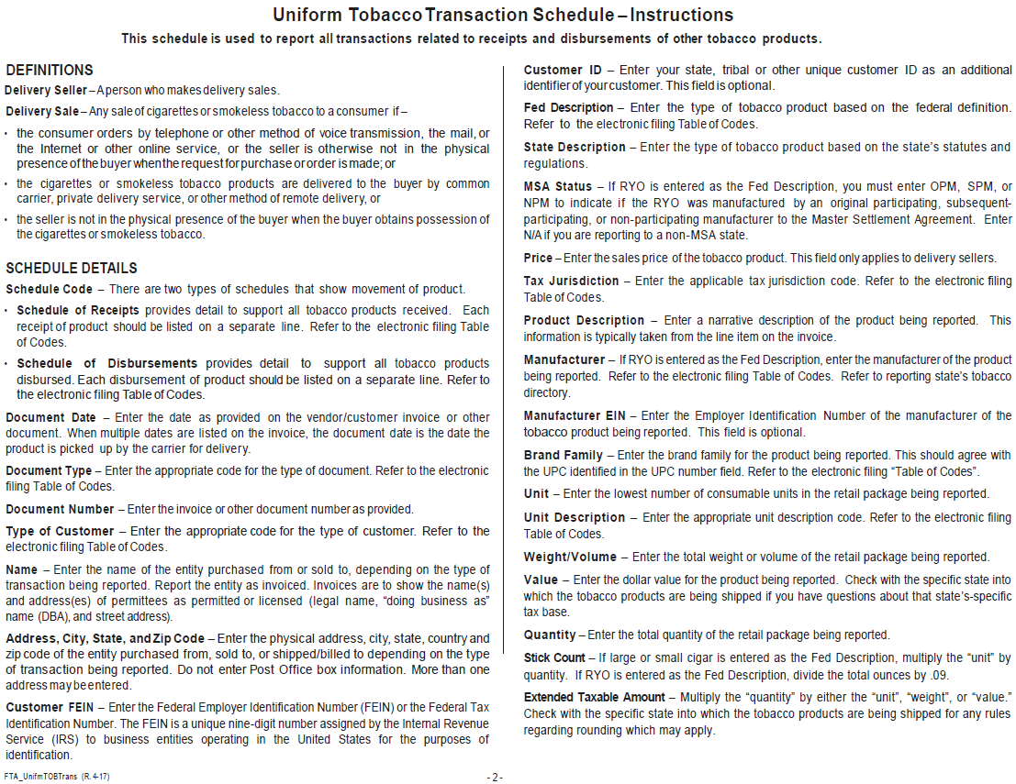

Cigarette Schedules of Receipts and Disbursements

Schedules of Receipts

Schedule 1 Cigarettes Received into Inventory

1A - Cigarettes received from a manufacturer or first importer.

Intended Use:

Filer is reporting cigarettes received that were purchased from the original manufacturer or first importer. Refer to the “Tax Jurisdiction” data field to determine which jurisdiction’s tax stamp has been affixed, if any.

1B - Cigarettes received from a person other than a manufacturer or first importer, (e.g., a wholesaler, distributor, or other licensee).

Intended Use:

Filer is reporting cigarettes received from a person other than a manufacturer or first importer, (e.g., a wholesaler, distributor, or other licensee.) Refer to the “Tax Jurisdiction” data field to determine which jurisdiction’s tax stamp has been affixed, if any.

1C - Cigarettes received from a customer.

Intended Use:

Filer is reporting cigarettes received that were returned by the customer. Refer to the “Tax Jurisdiction” data field to determine which jurisdiction’s tax stamp has been affixed, if any, or whether no stamp was affixed. Note that “Customer” in this context DOES NOT include manufacturer, first importer, vendor, or a person other than a manufacturer or first importer, (e.g., a wholesaler, distributor, or other licensee). “Customer” DOES include a retailer or reseller to consumers.

1D - Cigarettes received by a manufacturer or first importer from a person other than a manufacturer or first importer, (e.g., a wholesaler, distributor, or other licensee).

Intended Use:

Manufacturer is reporting the receipt of cigarettes returned by a person other than a manufacturer or first importer, (e.g., a wholesaler, distributor, or other licensee). Report each transaction on a separate schedule. Refer to the “Tax Jurisdiction” data field to determine which jurisdiction’s tax stamp has been affixed, if any, or whether no stamp was affixed. A manufacturer’s affidavit should be sent to the licensed wholesaler and is the paper document that will substantiate this transaction.

Schedules of Disbursements

Schedule 2 Cigarettes Disbursed from Inventory

2A Cigarettes disbursed by a manufacturer or first importer.

Intended Use:

Filer is reporting the sale of cigarettes. Refer to the “Tax Jurisdiction” data field to determine which jurisdiction’s tax stamp has been affixed, if any.

2B Cigarettes disbursed to a person other than a manufacturer or first importer, (e.g., a wholesaler, distributor, or other licensee).

Intended Use:

Filer is reporting the disbursement of cigarettes to a person other than a manufacturer or first importer, (e.g., a wholesaler, distributor, or other licensee). Refer to the “Tax Jurisdiction” data field to determine which jurisdiction’s tax stamp has been affixed, if any.

2C Cigarettes disbursed to a customer.

Intended Use:

Filer is reporting the sale of cigarettes to customers (e.g., retailer, employee, or other direct consumer.) Refer to the “Tax Jurisdiction” data field to determine which jurisdiction’s tax stamp has been affixed, if any. Note that “Customer” in this context DOES NOT include manufacturer, first importer, vendor, or a person other than a manufacturer or first importer, (e.g., a wholesaler, distributor, or other licensee). “Customer” DOES include a retailer or reseller to consumers.

2D Cigarettes returned to the manufacturer.

Intended Use:

Filer is reporting the return of cigarettes to the manufacturer. Report each transaction on a separate schedule. Refer to the “Tax Jurisdiction” data field to determine which jurisdiction’s tax stamp has been affixed, if any, or whether no stamp was affixed. Credit for tax stamps is not given by the reporting of this transaction. This schedule is used to report the removal of cigarettes from inventory. A manufacturer’s affidavit should be received from the manufacturer and sent to the state for credit. (A manufacturer’s affidavit is the paper document that will substantiate this transaction.)

Tobacco Schedules of Receipts and Disbursements

Schedules of Receipts

Schedule 1 OTP Shipments Received

1A - OTP received from a manufacturer or first importer.

Intended Use:

Filer is reporting OTP received that was purchased from the original manufacturer or first importer. Refer to the “Tax Jurisdiction” data field to determine which jurisdiction’s tax has been paid, if any.

1B - OTP received from a person other than a manufacturer or first importer, (e.g., a wholesaler, distributor, or other licensee).

Intended Use:

Filer is reporting OTP received from a person other than a manufacturer or first importer, (e.g., a wholesaler, distributor, or other licensee). Refer to the “Tax Jurisdiction” data field to determine which jurisdiction’s tax has been paid, if any.

1C - OTP received from a customer.

Intended Use:

Filer is reporting OTP received that was returned by the customer. Refer to the “Tax Jurisdiction” data field to determine which jurisdiction’s tax has been paid, if any. Note that “Customer” in this context DOES NOT include manufacturer, first importer, vendor, or a person other than a manufacturer or first importer, (e.g., a wholesaler, distributor, or other licensee). “Customer” DOES include a retailer or reseller to consumers.

1D - OTP received by a manufacturer or first importer from a person other than a manufacturer or first importer, (e.g., a wholesaler, distributor, or other licensee).

Intended Use:

Manufacturer is reporting the receipt of OTP returned by a person other than a manufacturer or first importer, (e.g., a wholesaler, distributor, or other licensee). Report each transaction on a separate schedule. Refer to the “Tax Jurisdiction” data field to determine which jurisdiction’s tax has been paid, if any. A manufacturer’s affidavit should be sent to the licensed distributor and is the paper document that will substantiate this transaction.

Schedules of Disbursements

Schedule 2 OTP Shipments Disbursed

2A OTP disbursed by a manufacturer or first importer.

Intended Use:

Filer is reporting the sale of OTP. Refer to the “Tax Jurisdiction” data field to determine which jurisdiction’s tax has been paid, if any.

2B OTP disbursed to a person other than a manufacturer or first importer, (e.g., a wholesaler, distributor, or other licensee).

Intended Use:

Filer is reporting the disbursement of OTP to a person other than a manufacturer or first importer, (e.g., a wholesaler, distributor, or other licensee). Refer to the “Tax Jurisdiction” data field to determine which jurisdiction’s tax has been paid, if any.

2C OTP disbursed to a customer.

Intended Use:

Filer is reporting the disbursement of OTP to customers, (e.g., retailer, employee, or other direct consumer). Refer to the “Tax Jurisdiction” data field to determine which jurisdiction’s tax has been paid, if any. Note that “Customer” in this context DOES NOT include manufacturer, first importer, vendor, or a person other than a manufacturer or first importer, (e.g., a wholesaler, distributor, or other licensee). “Customer” DOES include a retailer or reseller to consumers.

2D OTP returned to the manufacturer or importer.

Intended Use:

Filer is reporting the return of OTP to the manufacturer. Report each transaction on a separate schedule. Refer to the “Tax Jurisdiction” data field to determine which jurisdiction’s tax has been paid, if any. Credit for tax paid is not given by the reporting of this transaction. This schedule is used to report the removal of tobacco product from inventory. A manufacturer’s affidavit should be received from the manufacturer and sent to the state for credit. (A manufacturer’s affidavit is the paper document that will substantiate this transaction.)

Uniform Purchase-Based Tobacco Cover Page for ______________
(Identify the reporting state tax jurisdiction)
Taxpayer Name (please print) |  |  |  | Reporting Period (MM/YYYY) | State Identification Number
Location Address (number and street) | City | State/Province | Zip Code/Postal Code | Country/Territory | Federal Employer Identification Number (FEIN)
Mailing Address | City | State/Province | Zip Code/Postal Code | Country/Territory | Email Address

 | Original Return |  |  | Amended Return |  |  | Replacement Return |  |  | In-state Filer |  |  | Out-of-State Filer

 |  |  |  | State Description 1 | State Description 2 | State Description 3 | Total
Gross Taxable Transactions |  |  | Schedule #
 | 1 | Purchases of untaxed product | 1A
 | 2 | Exports - Out of State Customer Returns | 1C - OOS & 1B - OOS
 | 3 | Gross Taxable Transactions (add lines 1 - 2)
Reductions
 | 4 | Exports - Out of State Customer Sales | 2C - OOS & 2B - OOS
 | 5 | Returns to Manufacturer | 2D
 | 6 | Exempt Sales -
 | 6a | Native | 1C & 2C - Native - IS
 | 6b | Licensed Distributor | 1B & 2B - Licensed - IS
 | 6c | Military, Government or other Exempt transaction | 1C & 2C - Govt - IS
 | 7 | Total Subtractions (add lines 4 - 6)
 | 8 | Net Taxable Amount (line 3 less line 7)
 | 9 | Tax Rate by State Description
 | 10 | Tax Amount (line 8 times line 9)
 | 11 | Less Timely Filing Discount (if applicable)
 | 12 | Net Tax (line 10 less line 11)
 | 13 | Total Net Tax from Other Pages (if more State Descriptions)
 | 14 | Carry Over Adjustment - Amount owed or credit
 | 15 | Tax Due (add lines 12 - 15)
 | 16 | Penalty
 | 17 | Interest
 | 18 | Total Due (add lines 16 - 18)
 | 19 | Purchases of tax-paid tobacco products (informational only)

I declare that I have examined this form and to the best of my knowledge and belief it is true, correct and complete.

_________________________________ ________________________ __________________
Name Title Date

Uniform Purchase-Based Tobacco Cover Page – Instructions

This Cover Page is used to calculate and report tobacco tax due for the period when tax is computed based on PURCHASES made during the reporting period. This form is most commonly used by an in-state Taxpayer.

Data used to populate this Cover Page is pulled directly from the Taxpayer’s Uniform Tobacco Transaction Schedules (“UTTS”) for the Reporting Period. Key data pulled includes – State Description Code, Schedule Code, Type of Customer, Tax Jurisdiction, and Extended Taxable Amount.

SCHEDULE DETAILS

Taxpayer Name – Enter the Name of the Taxpayer filing this report. Name should agree with the Name as shown on the Taxpayer’s state license.

Reporting Period – Enter the month and year of the tax period being reported. For a quarterly or annual filing period, enter the last month of the reporting period.

State Identification Number – Enter the State Identification Number of the Taxpayer. This is a unique identifier assigned to the Taxpayer by the reporting state.

Location Address – Enter the physical address, city, state, country and zip code of the Taxpayer. Do not enter Post Office box information.

Mailing Address – Enter the mailing address, city, state, country and zip code of the Taxpayer.

Taxpayer FEIN - Enter the Federal Employer Identification Number (FEIN) or the Federal Tax Identification Number. The FEIN is a unique nine-digit number assigned by the Internal Revenue Service (IRS) to business entities operating in the United States for the purposes of identification.

Email Address – Enter the Email Address of the Taxpayer’s contact.

Original Return / Amended Return / Replacement Return – Mark the box for the report being filed. Original Return should be marked if this is the first time a report has been filed for this reporting period. Amended Return should be marked if an amendment to the Original Return is being filed after the original due date. Mark the Replacement Return box if this report is correcting an Original Return prior to the original due date.

In-State Filer / Out-of-State Filer – Mark the appropriate box based on whether the Taxpayer’s physical location is inside or outside the reporting state.

State Description Code – The reporting state will pre-define their State Description Codes (Codes to replace the 1, 2, 3 shown). Depending on the state’s statutes and regulations, some states may only have 1 State Description Code (i.e., 1 column of data) while other states may have multiple State Description Codes (requiring multiple columns on this Cover Page and possibly multiple pages to this form). Data for each State Description Code should be pulled from the Taxpayer’s UTTSs for the Reporting Period and placed in the corresponding State Description column of the Cover Page.

1 – Purchases of untaxed product –Enter the total Extended Taxable Amount, as reflected on the UTTSs for Schedule Code “1A”, for untaxed tobacco received (i.e., with no Tax Jurisdiction) by the Taxpayer. These amounts should be placed into the respective State Description Columns based on the State Description Codes on the UTTS.

2 – Exports – Out of State Customer Returns – Enter the total Extended Taxable Amount, as reflected on the UTTSs for Schedule Code “1B” and “1C”, for tobacco received by the Taxpayer. Amounts should include only tobacco received from Tax Jurisdictions outside the reporting state (“OOS”).

3 – Gross Taxable Transactions – Add rows 1 and 2 by State Description Code.

4 – Exports – Out of State Customer Sales –Enter the total Extended Taxable Amount, as reflected on the UTTSs for Schedule Codes “2B” and “2C”, for tobacco disbursed to Tax Jurisdictions outside the reporting state (“OOS”).

5 – Returns to Manufacturer - Enter the total Extended Taxable Amount, as reflected on the UTTSs for Schedule Codes “2D”, for tobacco disbursed to Type of Customer “Manufacturer”.

6a - Native – If applicable, enter the total Extended Taxable Amount, as reflected on the UTTSs for Schedule Codes “1C” and “2C” , for tobacco received by or disbursed to solely Type of Customer “Native” (as defined by state statutes and regulations) within the reporting state (“IS”).

6b - Licensed Distributor – If applicable, enter the total Extended Taxable Amount, as reflected on the UTTSs Schedule Codes “1C” and “2C”, for tobacco received by or disbursed to solely Type of Customer “Distributor” or “Wholesaler” or “Inter-branch Transfer” (as defined by state statutes and regulations) within the reporting state (“IS”).

6c - Military, Government or other Exempt Customer – If applicable, enter the total Extended Taxable Amount, as reflected on the UTTSs for Schedule Codes “1C” and “2C”, for tobacco received by or disbursed to solely Type of Customer “Military” or “Government” (as defined by state statutes and regulations) within the reporting state (“IS”).

7 – Total Subtractions – Add rows 4, 5 and 6a to 6c by State Description Code.

8 – Net Taxable Amount – Subtract row 7 from row 3 by State Description Code. Note that these amounts may be a value ($), a number of units or a weight/volume depending on the State Description Code requirement.

9 – Tax Rate by State Description - The reporting state will pre-define their tax rates by State Description Code.

10 – Tax amount – Multiply row 8 by row 9. The resulting amount will be a dollar amount. Include a cross-foot Total for this row.

11 – Timely Filing Discount – If applicable, indicate the timely filing discount. This amount may be a percentage of row 10 with or without a dollar cap. Amounts may be computed by State Description Code or only in Total. If by State Description Code, include a cross-foot Total for this row.

12 – Net Tax – Subtract row 11 from row 10.

13 - Net Tax from Other Pages – To the extent that the reporting state has multiple State Description Codes that do not all fit on 1 Cover Page, multiple Cover Pages may be needed. This row is used to carry all State Description Net Tax totals to the front Cover Page.

14 - Carry Over Adjustment – Amount owed or credit – Use this row to present any prior period adjustment carrying into this Reporting Period.

15 - Tax Due – Add rows 12 to 14. This is your Total Tax Due.

16 - Penalty – To the extent this report is filed late, penalties may be due. Enter here the penalty amount due.

17 - Interest - To the extent this report is filed late, interest may be due. Enter her the interest amount due.

18 - Total Due – Add rows 15 to 17. The amount paid by the Taxpayer to the reporting state with this report should equal this amount.

19 – Purchases of tax-paid tobacco products – Enter the total Extended Taxable Amount, as reflected on the UTTSs for Schedule Code “1A” (OTP received from a manufacturer or first importer) or “1B” (OTP received from a person other than a manufacturer or first importer), for tax paid tobacco received (i.e., with an in-state Tax Jurisdiction) by the Taxpayer during the Reporting Period.

Uniform Sales-Based Tobacco Cover Page for ______________
(Identify the reporting state jurisdiction)

Taxpayer Name (please print) |  |  |  | Reporting Period (MM/YYYY) | State Identification Number
Location Address (number and street) | City | State/Province | Zip Code/Postal Code | Country/Territory | Federal Employer Identification Number (FEIN)
Mailing Address | City | State/Province | Zip Code/Postal Code | Country/Territory | Email Address

 | Original Return |  |  | Amended Return |  |  | Replacement Return |  |  | In-state Filer |  |  | Out-of-State Filer

 |  |  |  | State Description 1 | State Description 2 | State Description 3 | Total
Gross Taxable Transactions |  |  | Schedule #
 | 1 | Gross Sales Amount (sales to customers) | 2C & 2B
Reductions
 | 2 | In State Returns (Returns from customers within reporting state) | 1C - IS & 1B - IS
 | 3 | Exempt Sales -
 | 3a | Native | 1C & 2C - Native - IS
 | 3b | Licensed Distributor | 1B & 2B - Licensed - IS
 | 3c | Military, Government or other Exempt transaction | 1C & 2C - Govt - IS
 | 3d | Exports (out-of-state customer sales) | 2C - OOS & 2B -OOS
 | 4 | Total Subtractions (add lines 2 – 3d)
 | 5 | Net Taxable Amount (line 1 less line 4)
 | 6 | Tax Rate by State Description
 | 7 | Tax Amount (line 5 times line 6)
 | 8 | Less Timely Filing Discount (if applicable)
 | 9 | Net Tax (line 7 less line 8)
 | 10 | Total Net Tax from Other Pages (if more State Descriptions)
 | 11 | Carry Over Adjustment - Amount owed or credit
 | 12 | Tax Due (add lines 9 - 11)
 | 13 | Penalty
 | 14 | Interest
 | 15 | Total Due (add lines 12 - 14)

I declare that I have examined this form and to the best of my knowledge and belief it is true, correct and complete.

_________________________________ ________________________ __________________
Name Title Date

Uniform Sales-Based Tobacco Cover Page – Instructions

This Cover Page is used to calculate and report tobacco tax due for the period when tax is computed based on SALES made during the reporting period. This form is most commonly used by an out-of-state Taxpayer.

Data used to populate this Cover Page is pulled directly from the Taxpayer’s Uniform Tobacco Transaction Schedules (“UTTS”) for the Reporting Period. Key data pulled includes – State Description Code, Schedule Code, Type of Customer, Tax Jurisdiction, and Extended Taxable Amount.

SCHEDULE DETAILS

Taxpayer Name – Enter the Name of the Taxpayer filing this report. Name should agree with the Name as shown on the Taxpayer’s state license.

Reporting Period – Enter the month and year of the tax period being reported. For a quarterly or annual filing period, enter the last month of the reporting period.

State Identification Number – Enter the State Identification Number of the Taxpayer. This is a unique identifier assigned to the Taxpayer by the reporting state.

Location Address – Enter the physical address, city, state, country and zip code of the Taxpayer. Do not enter Post Office box information.

Mailing Address – Enter the mailing address, city, state, country and zip code of the Taxpayer.

Taxpayer FEIN - Enter the Federal Employer Identification Number (FEIN) or the Federal Tax Identification Number. The FEIN is a unique nine-digit number assigned by the Internal Revenue Service (IRS) to business entities operating in the United States for the purposes of identification.

Email Address – Enter the Email Address of the Taxpayer’s contact.

Original Return / Amended Return / Replacement Return – Mark the box for the report being filed. Original Return should be marked if this is the first time a report has been filed for this reporting period. Amended Return should be marked if an amendment to the Original Return is being filed after the original due date. Mark the Replacement Return box if this report is correcting an Original Return prior to the original due date.

In-State Filer / Out-of-State Filer – Mark the appropriate box based on whether the Taxpayer’s physical location is inside or outside the reporting state.

State Description Code – The reporting state will pre-define their State Description Codes (Codes to replace the 1, 2, 3 shown). Depending on the state’s statutes and regulations, some states may only have 1 State Description Code (i.e., 1 column of data) while other states may have multiple State Description Codes (requiring multiple columns on this Cover Page and possibly multiple pages to this f the UTTSs for Schedule Codes “2B” and “2C”, for tobacco disbursed by the Taxpayer. These amounts should be placed into the respective State Description Columns orm). Data for each State Description Code should be pulled from the Taxpayer’s UTTSs for the Reporting Period and placed in the corresponding State Description column of the Cover Page.

1 - Gross Sales Amount –Enter the total Extended Taxable Amount, as reflected on based on the State Description Codes on the UTTS.
For an In-State Filer, 2B and 2C amounts should be included for all UTTS transactions (for all Tax Jurisdictions whether inside or outside the reporting state).
For an Out-of-State Filer, only include 2B and 2C amounts for transactions occurring within the reporting state.

2 - In-State Returns – Enter the total Extended Taxable Amount, as reflected on the UTTSs for Schedule Code “1B” and “1C”, for tobacco received by the Taxpayer. Amounts should include only transactions occurring within the reporting state (“IS”).

3a - Native – If applicable, enter the total Extended Taxable Amount, as reflected on the UTTSs for Schedule Codes “1C” and “2C”, for tobacco received by or disbursed to solely Type of Customer “Native” (as defined by state statutes and regulations) within the reporting state (“IS”).

3b - Licensed Distributor – If applicable, enter the total Extended Taxable Amount, as reflected on the UTTSs for Schedule Codes “1C” and “2C”, for tobacco received by or disbursed to solely Type of Customer “Distributor” or “Wholesaler” or “Inter-branch Transfer” (as defined by state statutes and regulations) within the reporting state (“IS”).

3c - Military, Government or other Exempt Customer – If applicable, enter the total Extended Taxable Amount, as reflected on the UTTSs for Schedule Codes “1C” and “2C”, for tobacco received by or disbursed to solely Type of Customer “Military” or “Government” (as defined by state statutes and regulations) within the reporting state (“IS”).

3d - Exports – This row applies only to In-State Filers. Enter the total Extended Taxable Amount, as reflected on the UTTSs for Schedule Codes “2B” and “2C”, for tobacco disbursed to Tax Jurisdictions outside the reporting state (“OOS”).

4 – Total Subtractions – Add rows 2 and 3a to 3d by State Description Code.

5 – Net Taxable Amount – Subtract row 4 from row 1 by State Description Code. Note that these amounts may be a value ($), a number of units or a weight/volume depending on the State Description Code requirement.

6 – Tax Rate by State Description - The reporting state will pre-define their tax rates by State Description Code.

7 – Tax amount – Multiply row 5 by row 6. The resulting amount will be a dollar amount. Include a cross-foot Total for this row.

8 – Timely Filing Discount – If applicable, indicate the timely filing discount. This amount may be a percentage of row 7 with or without a dollar cap. Amounts may be computed by State Description Code or only in Total. If by State Description Code, include a cross-foot Total for this row.

9 – Net Tax – Subtract row 8 from row 7.

10 - Net Tax from Other Pages – To the extent that the reporting state has multiple State Description Codes that do not all fit on 1 Cover Page, multiple Cover Pages may be needed. This row is used to carry all State Description Net Tax totals to the front Cover Page.

11 - Carry Over Adjustment – Amount owed or credit – Use this row to present any prior period adjustment carrying into this Reporting Period.

12 - Tax Due – Add rows 9 to 11. This is your Total Tax Due.

13 - Penalty – To the extent this report is filed late, penalties may be due. Enter here the penalty amount due.

14 – Interest – To the extent this report is filed late, interest may be due. Enter here the interest amount due.

15 – Total Due- Add rows 12 to 14. The amount paid by the Taxpayer to the reporting state with this report should equal this amount.

Electronic Filing Receipt Acknowledgement

It is encouraged to send an acknowledgment when a report is received electronically. Below are suggestions to include in the content of the acknowledgement. Any information to help industry identify what you are acknowledging is helpful. One e-file acknowledgement should be issued for each transmission.

- State

- License number / State identification number

- Taxpayer (Company) name

- Reporting period

- Date received

- Type of tax

- Type of return (original, superseded, amended, etc.)

- Status of filing

- Name and phone number of person to contact for questions/issues

- Name of file(s) submitted, if applicable

- Confirmation number, if applicable

- Total dollar amount, if applicable

- Total lines, if applicable

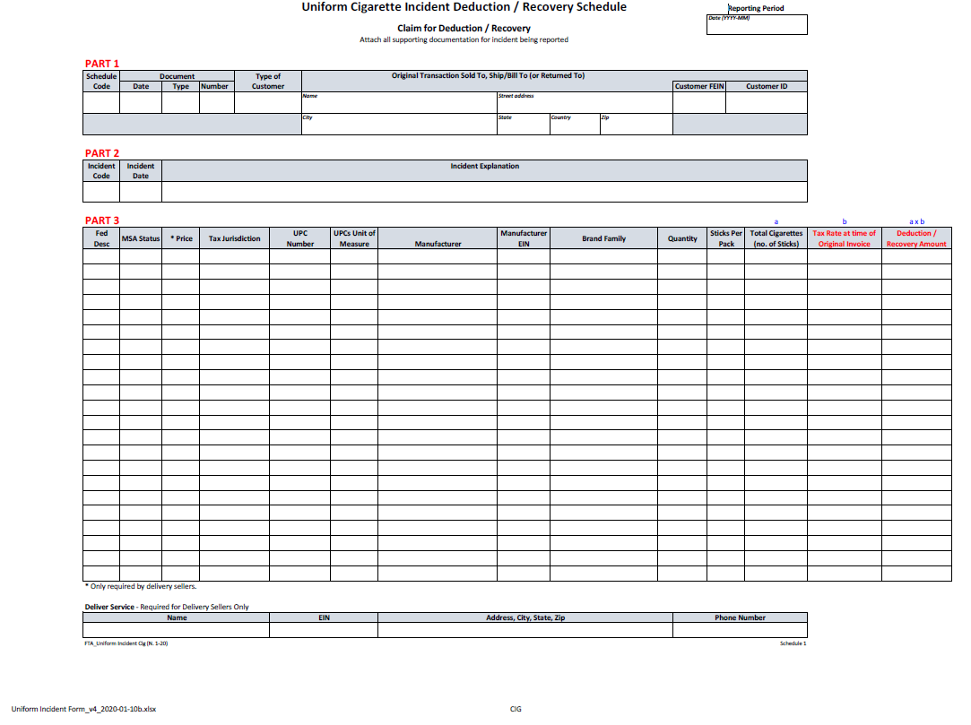
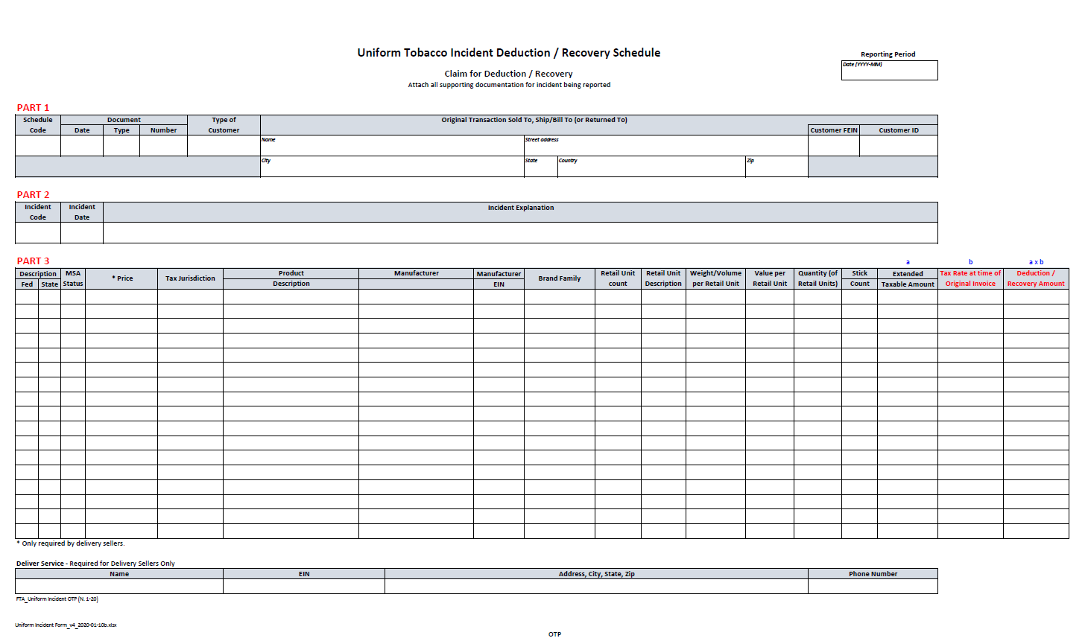

Uniform Incident Form – Instructions
This Incident Form is used to report incidents that cause an adjustment to inventory or result in a change in a tax calculation. For example, to report a theft, destruction or bad debt claim, etc.

SCHEDULE DETAILS
Part I – Data used to populate Part 1 of this Incident Form is pulled directly from the Taxpayer’s Uniform Transaction Schedule (“UTS”) for the Reporting Period in which the Originating Transaction, if any, occurred. For example, the original sales transaction for which a bad debt is claimed, the original purchase transaction for stolen or destroyed product, etc.). To the extent there is no originating transaction, leave this section blank.
Schedule Code – There are two types of schedules that show movement of product.
- Schedule of Receipts provides detail to support all tobacco or cigarette products received. Each receipt of product should be listed on a separate line. Refer to the electronic filing Table of Codes.
- Schedule of Disbursements provides detail to support all tobacco or cigarette products disbursed. Each disbursement of product should be listed on a separate line. Refer to the electronic filing Table of Codes.
Document Date – Enter the date as provided on the vendor/customer invoice or other document. When multiple dates are listed on the invoice, the document date is the date the product is picked up by the carrier for delivery.
Document Type – Enter the appropriate code for the type of document. Refer to the electronic filing Table of Codes.
Document Number – Enter the invoice or other document number as provided.
Type of Customer – Enter the appropriate code for the type of customer. Refer to the electronic filing Table of Codes.
Name – Enter the name of the entity purchased from or sold to, depending on the type of transaction being reported. Report the entity as invoiced. Invoices are to show the name(s) and address(es) of permittees as permitted or licensed (legal name, “doing business as” name (DBA), and street address).
Address, City, State, and Zip Code – Enter the physical address, city, state, country and zip code of the entity purchased from, sold to, or shipped/billed to depending on the type of transaction being reported. Do not enter Post Office box information. More than one address may be entered.
Customer FEIN – Enter the Federal Employer Identification Number (FEIN) or the Federal Tax Identification Number. The FEIN is a unique nine‐ digit number assigned by the Internal Revenue Service (IRS) to business entities operating in the United States for the purposes of identification.
Customer ID – Enter your state, tribal or other unique customer ID as an additional identifier of your customer. This field is optional.

Part 2 – Detail regarding the incident being reported.

Incident Code – Select the code which best describes the type of incident being reported. Refer to the electronic filing Table of Codes
Incident Date – Enter the date on which the incident occurred, for example, the date of a theft or destruction of product, the date when the bad debt occurred, etc. If multiple dates exist for this incident (i.e., date first reported bad debt to state, date of write‐off of bad debt in taxpayer books and records, etc.) refer to the state specific requirements regarding the date to enter in this data field.
Incident Explanation – Describe in detail the nature of the incident being reported. This explanation should include reference to documents to be provided in support of this incident – i.e., police reports, documentation in support of attempts to collect on bad debt, etc.

Part 3 – Description of product lost, stolen, destroyed or written‐off as a result of this incident. Note that the Fed Description, State Description (if applicable), MSA Status, Tax Jurisdiction, Product Description, UPC Code, Manufacturer, Manufacturer EIN and Brand should agree with the information originally provided during the Reporting Period of the Originating Transaction.

Tobacco Incident Form –

Fed Description – Enter the type of tobacco product based on the federal definition. Refer to the electronic filing Table of Codes.
State Description – Enter the type of tobacco product based on the state’s statutes and regulations.
MSA Status – If RYO is entered as the Fed Description, you must enter OPM, SPM, or NPM to indicate if the RYO was manufactured by an original participating, subsequent‐participating, or non‐participating manufacturer to the Master Settlement Agreement. Enter N/A if you are reporting to a non‐MSA state.
Price – Enter the sales price of the tobacco product. This field only applies to delivery sellers.
Tax Jurisdiction – Enter the applicable tax jurisdiction code. Refer to the electronic filing Table of Codes.
Product Description – Enter a narrative description of the product being reported. This information is typically taken from the line item on the invoice.
Manufacturer – If RYO is entered as the Fed Description, enter the manufacturer of the product being reported. Refer to the electronic filing Table of Codes. Refer to reporting state’s tobacco directory.
Manufacturer EIN – Enter the Employer Identification Number of the manufacturer of the tobacco product being reported. This field is optional.
Brand Family – Enter the brand family for the product being reported. This should agree with the UPC identified in the UPC number field. Refer to the electronic filing Table of Codes.
Retail Unit count – Enter the lowest number of consumable units in the retail package being reported.
Retail Unit Description – Enter the appropriate unit description code. Refer to the electronic filing Table of Codes.
Weight/Volume per Retail Unit – Enter the total weight or volume of the retail package being reported.
Value per Retail Unit – Enter the dollar value for the product being reported. Check with the specific state into which the tobacco products are being shipped if you have questions about that state’s specific tax base.
Quantity (of Retail Units)– Enter the total quantity of the retail package being reported.
Stick Count – If large or small cigar is entered as the Fed Description, multiply the “unit” by quantity. If RYO is entered as the Fed Description, divide the total ounces by .09.
Extended Taxable Amount – Multiply the “quantity” by either the “unit”, “weight”, or “value.” Check with the specific state into which the tobacco products are being shipped for any rules regarding rounding which may apply.
Tax Rate at time of Original Invoice – Enter the state tax rate applicable to this tobacco product (based on the State Description code) on the date on which the transaction originated. As an example, the date the stolen product was originally purchased or the date the product was originally sold to the customer for whom a bad debt is being claimed. Refer to State specific instructions as to which date to enter here.
Deduction / Recovery Amount – This is the dollar amount for which a deduction or recovery is being claimed. Enter a dollar amount equal to the “Extended Taxable Amount” times the “Tax Rate at the time of the Original Invoice”.
Cigarette Incident Form –

Fed Description – Enter the type of cigarette based on the federal definition. Refer to the electronic filing Table of Codes.
MSA Status – Enter OPM, SPM, or NPM to indicate if the cigarette was manufactured by an original participating, subsequent‐participating, or non‐participating manufacturer to the Master Settlement Agreement. Enter N/A if you are reporting to a non‐MSA state.
Price – Enter the sales price of the cigarettes. This field only applies to delivery sellers.
Tax Jurisdiction – Enter the applicable tax jurisdiction code. Refer to the electronic filing Table of Codes.
UPC Number – Enter the Universal Product Code (UPC) assigned to the product brand you are reporting.
UPCs Unit of Measure – Enter the unit of measure of the UPC being reported. PAK identifies packs, CAR identifies cartons, CSE identifies case.
Manufacturer – Enter the manufacturer of the cigarettes being reported. Refer to reporting state’s tobacco directory.
Manufacturer EIN – Enter the Employer Identification Number of the manufacturer of the cigarettes being reported. This field is optional.

Brand Family – Enter the brand family for the product being reported. This should agree with the UPC identified in the UPC number field. Refer to the electronic filing Table of Codes.

Quantity – Enter the total quantity of the packs being reported.

Sticks Per Pack – Enter the total number of sticks per pack you are reporting.
Total Cigarettes (No. of sticks) – Enter the total number of cigarette sticks being reported for the transaction.
Tax Rate at time of Original Invoice – Enter the state tax rate per stick on the date on which the transaction originated. As an example, the date the stolen product was originally purchased or the date the product was originally sold to the customer for whom a bad debt is being claimed. Refer to State specific instructions as to which date to enter here.
Deduction / Recovery Amount – This is the dollar amount for which a deduction or recovery is being claimed. Enter a dollar amount equal to the “Total Cigarettes” times the “Tax Rate at the time of the Original Invoice”.

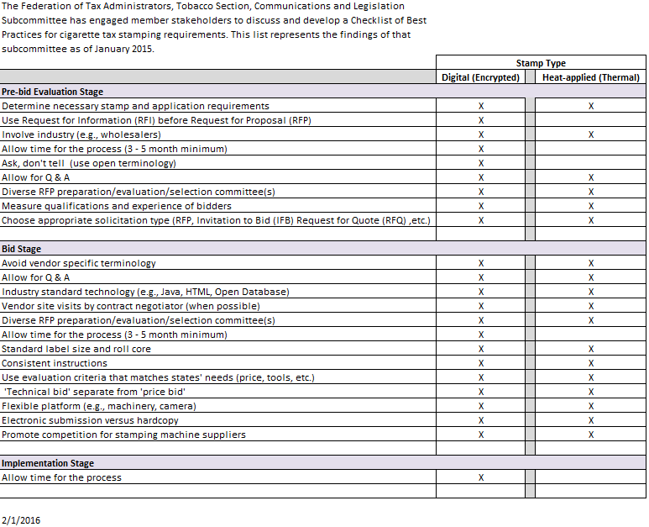

RFP Checklist for E-filing system

The Federation of Tax Administrators, Tobacco Section, Communications and Legislation Subcommittee have engaged member stakeholders to discuss and develop a Checklist of Best Practices for E-filing requirements. This list represents the findings of that subcommittee as of August 2019. This RFP checklist can also be used if a jurisdiction employs internal resources to design and create the e-file.
RFP Planning Stage (Pre-development)
Create a project plan – assign project leader
Establish timeframe for RFP responses
Determine what is in and out-of-scope (arbitration process)
Set size expectations of the project (based on # of filers, amount of data, number of returns involved [1,2,3 or more])
Adhere to FTA Uniformity Schema Standards
Define business rules and reporting tools
Develop a preliminary timeline
Plan for schema changes
Plan for increased data
Define post implementation support (service level agreement)
Development Stage
Work with procurement office
Ensure schema and schema modifications go through the Technology sub-committee of Uniformity Committee
Define number of interfaces needed with your back-end system (licensing, payments, stamp fulfillment, penalties, billing)
Establish payment schedules and milestones
Include audit workpapers in the scope of the work
Define output and reports (summary page vs detailed line-by-line)
Define acknowledgements and error messages
Confirm system is able to accommodate data requirements
Determine if vendor will be on-site or remote
Train personnel
Consider industry insight - have someone from industry come in and share thoughts
Soft launch vs hard launch date - may depend on whether converting from another eFile method
Plan communication and outreach
Allow filers 8 - 12 months for programming

RFP Checklist for E-fling system (con’t)

Implementation Stage
Follow the Uniform Guides -adhere to approved FTA XML schema
Use the FTA approved Brand Code Table - send to filers
Create, communicate, and post the development guide and schema
Communicate the importance of test files to the filers - small but robust test files
Create a test environment/testing infrastructure
Set up hard submission due dates for test files (well in advance of 'go-live')
Design & communicate the means for taxpayers to input the data (transmission method)
After small test files have been approved, allow a large test file to be submitted
Provide feedback on test data
Allow the taxpayer to view data (before processing) and print output
Excel to XML converter tool
Send new form information in acknowledgements for current XML filers
Hold trainings, webinars, conference calls
Connect with taxpayers and wholesaler associations
Meet legislatively mandated deadlines
Anticipate large file submissions - develop plan to process when file sizes grow
Post Implementation
Determine the fields available to crossmatch between two filers
Ability to import/export state data to another state (state-to-state sharing)
Connect gathered data to your audit workpapers
Provide post implementation support
Be prepared to offer extensions & waivers to taxpayers (optional)

White Papers

Purpose

A white paper is an authoritative report or guide that informs readers concisely about a complex issue and presents the issuing body's philosophy on the matter. It is meant to help readers understand an issue, solve a problem, or make a decision.

The following pages contain white papers that have been approved for publication by the FTA Tobacco Uniformity Committee for use by all states and industry.

Modified Risk Tobacco Products
Points to Consider Relative to Tobacco Tax Administration

Introduction
The Family Smoking Prevention and Tobacco Control Act of 2009 created a regulatory path for tobacco manufacturers to make certain health-related claims on specific tobacco products if they can show, after an extensive scientific review by the Food and Drug Administration (FDA), that the products are likely to benefit public health. These “Modified Risk Tobacco Products” (MRTP) are defined by section 911 of the Federal Food Drug and Cosmetic Act as “any tobacco product that is sold or distributed for use to reduce harm or the risk of tobacco related disease associated with commercially marketed tobacco products.”

The FDA can grant two different types of orders: Risk modification orders, or exposure modification orders. The FDA will issue a risk modification order (Section 911(g)(1)) if the product significantly reduces harm or the risk of tobacco-related disease to individual tobacco users, and benefits the health of the population as a whole taking into account both users of tobacco products and persons who do not currently use tobacco products. The FDA will issue an exposure order (Section 911(g)(2)) if the product reduces or eliminates exposure to a substance that the available scientific evidence suggests would have a measurable, positive impact on public health in future studies.

How do you get classified as a Modified Risk Tobacco Product?

Tobacco Product Manufacturers may file an application with the Food and Drug Administration for a MRTP. Applicants must describe the proposed tobacco product and provide any research related to the tobacco product, and its impact on human health. Sample products can be submitted as well as labeling and advertising information for the tobacco product. Within 60 days of submitting the application, the application is referred to the Tobacco Products Scientific Advisory Committee for the USFDA and they shall report its recommendations on the application to the Secretary. The Tobacco Products Scientific Advisory Committee’s ruling is not final -- it is ultimately up to the Secretary to determine if the product qualifies as a MRTP.

In October of 2019, the FDA granted modified risk product status to eight specific snus smokeless tobacco products sold by Swedish Match, USA under the brand name “General.” These were the first products granted this status. The products were granted a risk modification order under Section 911(g)(1). In July of 2020, the FDA granted modified risk product status to Philip Morris, S.A.’s IQOS system and three IQOS heatstick products. These products were granted an exposure order under Section 911(g)(2).

Effect on State Tobacco Excise Taxes

By itself, an MRTP designation does not affect the taxation of tobacco products. However, a few states have passed MRTP-related tax legislation. All of these laws reduce the rate of tax by a certain percentage for products granted MRPT status by FDA.

Some states differentiate by type of authorization granted. For example, Kentucky, North Carolina, and Washington reduce the tax by 50% if the FDA has issued a risk modification order under Section 911(g)(1). If the FDA has issued an exposure modification order under Section 911(g)(2), then the tax is reduced by 25%. Connecticut, however, reduces the tax by the same amount regardless of the MRTP designation.

Issues for States

This legislation was introduced very quickly in North Carolina and Kentucky. It is imperative that tax administrators reach out to legislative staff and let them know of these new tobacco products and product designations. Being ahead of the legislation will allow tax administrators to better prepare for the inevitable tasks that must be done such as form and system changes, and compliance issues. Most of these MRTP will be distributed in the same manner as Other Tobacco Products and should have the same age minimums of those products but statutes should be explicit on these issues.

Taxation of E‐cigarettes and Their Components

Introduction

E‐cigarettes are electronic devices that heat liquid – usually containing propylene glycol and glycerol, with or without nicotine, flavors – that is stored in disposable or refillable cartridges or a reservoir. In turn, this heated “e-liquid” is converted to an aerosol, or vapor, for inhalation. E‐cigarettes simulate the act of smoking without lighting, fire, smoke, or ashes. States define e‐cigarettes and their components differently for the purposes of taxation.

This white paper will focus on taxation of the product, and its components; and will not address other issues related to it.

Description of Products

Although e‐cigarettes have been in the U.S. market for more than a decade, the products continue to
evolve and grow in popularity due to advances in technology.

The first generation of e‐cigarettes were “closed systems.” These were the first style of e‐cigarettes and most resemble the traditional cigarette. In fact, they are often called “cigalikes.” These e‐cigarettes include both disposable and rechargeable options and use prefilled cartridges of liquid. The products are ready to use, and all components are sealed within the device. The products can be used a finite number of times before they are disposed.

Second and third generations of e‐cigarettes are more flexible in terms of options for the consumer and include both closed system products and “open system” products. These products can take a variety of shapes and sizes and often do not look like a cigarette. Later generation closed systems can look like pens or USB flash drives. Open systems are typically larger and modifiable, with parts that are generally interchangeable, and reusable. Consumers can manually refill these open systems with e-liquids that come in thousands of flavors and are sold in a variety of sizes. Second and third generation products can go by names such as “mods,” “vape pens,” “e-hookah,” “personal vaporizers,” and “electronic nicotine delivery systems (ENDS).”

According to the U.S. Centers for Disease Control, e‐ cigarettes are less harmful to individuals than smoking, which likely contributes to its popularity. Some smokers use it as a method to quit smoking combustible cigarettes and others use it in conjunction with traditional cigarettes or other tobacco products. As these are relatively new products, longer term effects are still being studied.

Federal I ssues Related to E‐cigarettes

In May 2016, the U.S. Food and Drug Administration (FDA) finalized a rule to regulate e‐cigarettes along with some Other Tobacco Products that were previously not regulated by the FDA (the effective date was August 8, 2016). The rule established a federal minimum age of 18 to purchase e‐cigarettes and other retail provisions.

More importantly, the rule required manufacturers to submit their e‐cigarettes to a premarket application process through FDA. Products on the market prior to February 15, 2007, were grandfathered in and exempt from the premarket approval process. Products on the market prior to August 2016 were allowed to stay on the market but had to submit to the premarket application process through the FDA by November 2018 in order to be in compliance. In 2017, the FDA extended the deadline to August 8, 2022. In 2019, responding to what FDA Commissioner Scott Gottlieb called an “epidemic‐ rise” in youth e‐cigarette use, FDA moved the deadline up to August 8, 2021, for all flavored e‐cigarettes, other than “tobacco,” “mint,” or “menthol.”

Various public health groups sued the FDA in the U.S. District Court for the District of Maryland over the Agency’s decision to extend the premarket application process. In May 2019, the court ruled in the plaintiff’s favor and established a new deadline of May 12, 2020, which was later extend to September 9, 2020 due to delays caused by the COVID-19 pandemic. Products for which an application is submitted by the deadline can remain on the market for one year while the FDA considers their application.

E‐cigarettes are not taxed by the federal government.

S tate T axati on of E‐cigarettes

States were slow to tax e-cigarettes but are rapidly catching up. E‐cigarettes are currently taxed by more than half the states, as well as Washington D.C., and several localities. This is a doubling in the number of states taxing the products in less than a year. These jurisdictions have taken different paths toward taxation and have applied different taxing methods.

General

E‐cigarettes present challenges for tobacco tax administration and enforcement. There are two main reasons for this. First, there are a variety of products that fit under the e-cigarette umbrella, from closed‐system disposables and refillable/reusable products that visually look like cigarettes, to more open‐system products such as personal vaporizers, and mods that look nothing like cigarettes. The lack of uniformity extends to how they are packaged – disposables are self‐contained, whereas refillable/reusable products may be sold along with extra cartridges.

Second, the distribution model is dramatically different from cigarettes and other tobacco products. In the traditional model that tobacco tax administrators are well acquainted with, tobacco products flow (with some exceptions) from the manufacturer to the wholesaler/distributor, and finally to the retailer. At the state level, these are taxed once at the wholesale level via excise taxes and may also be taxed at the retail counter through the general sales tax. For the tobacco tax administrator who deals with just the excise tax, that shrinks the universe of taxpayers dramatically and makes administration and enforcement much easier. Most closed‐system products follow this model.

However, open‐system products are typically sold outside this traditional chain through specialized “vape” shops or direct to consumer through the Internet. This expands the universe of potential taxpayers and makes identifying taxpayers more difficult for tax administrators

Method of Taxation

Tobacco taxes generally fall into two categories: Specific, per‐unit taxes; or ad valorum (Latin for “according to value”) taxes. Initially, states stuck to those two basic categories, whether they incorporated e‐cigarettes/vapor products into the existing tobacco products tax (e.g. MN), or created a new tax specifically for these products (e.g., LA, NC).

More recently, states have expanded the range of methods used to tax these products. New York has passed a tax that instead of being applied at the wholesale level, will be assessed at the retail level, similar to a sales tax. New hybrid taxes that apply different tax rates (and even different methods) depending on whether the e‐cigarettes are “open” or “closed” were passed in New Mexico and Washington.

In Washington, the tax is applied per unit but with different rates depending on the size and type of
product. For “accessible containers” (i.e., those intended to be opened) greater than 5 ml, the tax is
$0.09 per ml. However, for closed systems, the tax is $0.27 per ml.

In New Mexico, the tax can be either per unit or ad valorum, depending on the type of product. “Closed system cartridges” containing 5 ml or less of e‐liquid are taxed at $0.50 per unit. But “e‐liquid” sold outside of a “closed system cartridge” is subject to a tax of 12.5% of the product value.

A novel variation on the hybrid taxation method was proposed by the Governor of California in 2020. This would continue to tax these products under the existing ad valorum rate, but also apply a tax based on the amount of nicotine in the liquid, not the volume of liquid itself.

CASE STUDIES

Minnesota
Minnesota was the first state to tax e‐cigarette/vapor products, with passage of the “Tobacco Modernization and Compliance Act of 2010” (MN Session Laws 2010, Chapter 305, SF3055). This law broadened the definition of tobacco products in Minnesota to cover the wide variety of non‐traditional products appearing on the market. The law gave the Minnesota Department of Revenue the authority to tax these products at the existing Other Tobacco Product (OTP) rate (effective August 1, 2010). It is unclear how much tax collection actually occurred as the products were not widely available. For example, one public health study found that e‐cigarettes were not available in C‐Stores until the 3rd quarter of 2010, and it was not until the 2nd quarter of 2012 that they were available in all the markets tracked by Nielsen.1

In October of 2012, the Department of Revenue issued Revenue Notice #12‐10 to clarify their e‐ cigarettes/vapor products tobacco product tax. They highlighted the following statutory text that defined tobacco products:

““Tobacco Products” means any product containing, made, or derived from tobacco that is intended for human consumption, whether chewed, smoked, absorbed, dissolved, inhaled, snorted, sniffed, or ingested by any other means, or any component, part, or accessory of a tobacco product…”

It further clarified that a) the burden of proving that the nicotine in the e‐cigarette came from a non‐ tobacco source and thus was not taxable as a tobacco product was on the taxpayer; and, b) that assuming that the taxpayer sold cartridges “separately,” and could “isolate” the cost of a cartridge, that the tax would be assessed only on the cartridge. This latter issue was important as initially, the entire kit was subject to taxation. Before the DOR adjustment, this meant equal amounts of nicotine liquid were subject to dramatically different rates of tax depending solely on how they were packaged.

Tax Rate and Revenue
From 2010 to through June of 2013, the tax rate on e‐cigarettes and vapor products was 70% of the wholesale sales price. On July 1, 2013, the tax rose to 95% of the “wholesale sales price.”

Minnesota has limited visibility on revenues due to the way it collects the tax on OTP products. As mentioned above, wholesalers are simply required to report the wholesale sales price of nearly all OTP purchased each month on a single form. To the extent DOR has any visibility on revenue, it comes from some combination of DOR surveys of wholesalers, key searches, and various tobacco industry and market research data.

North Carolina
North Carolina passed a tax on “consumable vapor products” in 2014 (H.B. 1050), with an effective date of June 1, 2015. A “consumable vapor product” is “any nicotine liquid solution or other material containing nicotine that is depleted as a vapor product is used. This includes pre‐filled tanks used in rechargeable and non‐rechargeable (disposable) vapor products.”2

1 Diaz M., Huang, J., Chaloupka, F., “The Impact of Electronic Cigarette Sales on Cigarette Sales, 2007‐2013,” Institute for Health and Policy Research, University of Illinois at Chicago, September 2014. Online at http://www.sctcresearch.org/media/products/Huang_ECigs_SCTC_Sept2014.pdf.
2 North Carolina Department of Revenue, “Tax on Vapor Products: Frequently Asked Questions” 21 May 2015
Unlike Minnesota, which taxed vapor products using the existing (ad valorum) tax rate for OTP, North
Carolina created a separate, unit‐based rate specifically for these products ($0.05 per milliliter).

The legislature gave the North Carolina Department of Revenue 12‐months to develop the means to

administer and enforce the tax. Unlike Minnesota, which had a tax when the size of the industry was quite small and manageable, North Carolina was imposing a tax on a robust market with several hundred potential taxpayers. While many vapor products were still sold through the traditional tobacco manufacturer‐wholesaler‐retailer chain that was already part of the tax regime, vape shops were previously untaxed (excise tax) and largely unknown to the North Carolina DOR. In order to identify the universe of potential taxpayers, the North Carolina DOR queried the sales tax for terms like “vape,” “smoke,” etc., and then sent them letters alerting them to the new law. They set up an extensive frequently asked questions page designed to clarify any administrative issues for these new taxpayers.

North Carolina kept the same basic structure that was in place with cigarettes and OTP. “Wholesale Dealers” who already had a license could sell taxed vapor products to retailers. Vape shops that were not purchasing their products from licensed “wholesale dealers” or were mixing their consumable vapor product in house were required to be licensed and were liable for tax. These are referred to as “retail dealers.”

The tax is reported by the taxpayer on the same form one would file with North Carolina DOR were they selling OTP. However, unlike Minnesota, a separate section on the form was created to document information on vapor products. This was necessary because the OTP tax and consumable vapor product tax are both different rates and different types (ad valorum in the case of OTP, unit/volume‐based in the case of vapor). A side effect is that it allows North Carolina to have much greater visibility on revenues.

Tax Rate and Revenue
The tax rate for “consumable vapor product” is $0.05 per milliliter of consumable vapor (the liquid with
nicotine). In FY2018, North Carolina collected $4.5 million in revenue from the tax.

Louisiana
In June of 2015, Louisiana passed a tax on “consumable vapor products” of $0.05 milliliter, effective on
August 1, 2015.

The definition of “consumable vapor product,” tax‐rate, type (unit/volume‐based) and structure of the Louisiana tax regime is basically identical to that of North Carolina. One difference is that while North Carolina had a full year to implement, Louisiana was afforded just two months to have an entire tax regime for this newly taxable product.

Another key difference is how “retail dealers” report the tax. Louisiana “retail dealers” file a separate form. Because of this difference, Louisiana can identify revenues from both the traditional wholesaler chain and the retail dealers such as vape shops who make their own “consumable vapor product.”

Tax Rate and Revenue
The tax rate for “consumable vapor product” is $0.05 per milliliter of consumable vapor (the liquid with
nicotine). In FY2018, Louisiana collected $1.15 million in consumable vapor product taxes.

Challenges in Compliance

There are several challenges faced by both tax authorities and taxpayers in regard to the taxation of e‐ cigarettes. E‐cigarette tax definitions, rates and taxing methodologies vary by tax jurisdiction (both state and local). Some taxing authorities tax a percentage of the wholesale value, while others tax per unit or milliliter of e‐liquid. As discussed above, the variety of e-cigarettes on the market is diverse and policymakers must decide whether and how to tax these products perhaps based on the risk profile of the various products. In addition, identifying and licensing the taxpayer can be challenging with cigarette taxation. Due to the variety of ways an end consumer can purchase e‐cigarettes ‐ traditional tobacco retail distribution, vape shops, online purchase from in‐state as well as out‐of‐state/country vendors ‐ finding and taxing the taxpayer can be difficult. Once a taxing authority has identified taxpayers and determined a taxing methodology, they will likely want to obtain statistical information regarding the amount of tax collected under this category. Thus, the way the ‐cigarette tax information is collected is also important.

As indicated above, there are essentially 2 different methods used by taxing authorities to tax e‐
cigarettes:

- Volume ‐ a fixed $ amount per volume of e‐cigarette liquid, or
- Value ‐ % times a value (either cost or sales price) of the e‐cigarette

In order to properly calculate a tax imposed on e‐cigarettes, it is important that e‐cigarette manufacturers provide detailed product specifications for each individual item (stock keeping unit number or sku) sold indicating the volume of e‐cigarette liquid contained in each saleable unit. In addition, for a tax based on value, it is important to understand the various components contained in each individual saleable item because tax jurisdiction tax methodologies vary as to whether and how they tax the various components of an e‐cigarette. For example, for many tax jurisdictions, it is important to know whether the item in question contains nicotine. As an example, in Minnesota, the tax cannot be calculated unless the manufacturer provides information as to the percentage of total product value attributable solely to nicotine. From a taxpayer perspective, given the various methodologies taxing authorities employ to tax these products, it is a challenge to determine which e‐ cigarette products fall within each tax jurisdiction’s classifications of taxable products.

From an administrative perspective (i.e., for purposes of calculating the tax and auditing tax calculations), a tax based on volume is much easier to understand and administer than a tax based on value. In order to calculate and audit a tax based on volume, one only needs to know the volume of e‐ cigarette liquid contained in each product sold by manufacturers; as discussed above, this information should be required in all manufacturers’ product specifications. Once this volume is known for each product, the tax computation will be the same for all taxpayers. That is, a tax based on volume will not fluctuate based on the size, location, or profitability of the taxpayer.

A tax based on volume is generally only assessed on nicotine‐containing liquid, but can be assessed on all e-liquid, even those not containing nicotine. Since it is typically assessed per milliliter, in absolute terms this kind of tax affects the sellers of bottled e‐liquid more than it does retailers of finished products containing a small amount of e‐liquid (like pod vapes and cigalikes).

One notable advantage to taxing these products based on volume (per milliliter) as opposed to price (ad valorem) is that volume taxes do not apply to the delivery device when the e‐liquid and electronic device are sold together. As an analogy, this would be like taxing a pipe, when an excise tax should really only apply to the pipe tobacco.

A tax calculated on a value may, on its face, appear easier to calculate and administer. If the tax is imposed at retail (i.e., at the time of sale to the end consumer), then the tax could be easily computed in a manner similar to a sales tax. Auditing a tax based on “value” requires a detailed review of the taxpayer’s invoices. In the case of a tax computed on Wholesale Cost (i.e., the price the wholesaler pays to their vendor, either before or after discounts), the taxpayer’s purchase invoices must be closely inspected – prices charged by vendors will not be consistent from one taxpayer to the next. Similarly, a tax computed on Wholesale Sales Price (i.e., the price the wholesaler charges their customer), will also vary from one invoice to the next as wholesalers do not necessarily charge the same amount for the same product to all of their customers. These values can differ from invoice to invoice across the entire audit period making audit testing difficult. Vendor promotional items can also cause complexity in the determination of products taxed on a value. In addition, value must also be determined in the calculation of returns to vendor and/or export & exempt sales – transactions that don’t necessarily disclose a consistent value as determined at the time of original in‐state purchase or sale. Thus, the time required to prepare and audit an excise tax return calculated on value will likely exceed the time required for a return calculated on volume.

A tax calculated on a wholesale value is ostensibly a tax on the retailer as it is collected from the retailer by the wholesaler who remits it to the taxing authority. However, the cost is always passed on to the consumer in the form of higher prices. This type of tax is assessed on the cost of the product the retailer is charged when purchasing from the wholesaler. Often the state classifies e‐cigarettes as tobacco products (or “other tobacco products,”) for purposes of assessing the tax. The wholesale tax may be assessed only on products that contain nicotine, or it may apply to all e‐liquid, or all products including devices that do not contain e‐liquid. Examples include California and Pennsylvania. The California vape tax is a wholesale tax that is set yearly by the state and is equal to the combined rate of all the taxes on cigarettes. It only applies to products that contain nicotine. The Pennsylvania vape tax originally applied to all products, including devices and even accessories that don’t include e‐liquid or nicotine, but due to a court ruling the state modified their definition to impose tax only on devices that contain nicotine.

Because e‐cigarettes are not covered by PACT Act, gathering statistical data regarding sales of e‐ cigarettes within the taxing jurisdiction can be challenging. Therefore, when a tax authority develops an excise tax form which includes a tax on e‐cigarettes, consideration should be given as to whether the e‐cigarette tax component should be separately disclosed on the tax form. For example, North Carolina has a completely separate tax form for vapor taxes, whereas California just includes e‐ cigarettes within the existing “Other Tobacco” category. Thus North Carolina can easily determine the amount of tax collected from e‐cigarette taxation.

Challenges of Marking/Stamping E‐Cigarettes

Marking, or stamping OTP can come with a wealth of challenges attached to them, some regulatory and some logistical. That extends to e‐cigarettes as well. Regulatory hurdles involve staying in line with the FDA’s regulations regarding tobacco products and making sure that markings do not interfere with the warnings that the FDA already have in place. The logistical issues come into play once the products form factors are considered, specifically size and shape. First, the pods for e‐cigarettes are already miniscule as currently constructed, potentially causing issues when locating a place for a warning and/or a stamp. Second, if a location for a warning label is finally found, how would the stamp be affixed consistently across form factors? All these hurdles are important to consider when thinking about applying markings to e‐cigarettes. Costs which follow stamping e‐cigarettes are another thing to consider before any decisions are made. The marking of OTP is something that will need to be backed by wholesalers with costs coming both directly and indirectly. Some of the costs that could become burdens for wholesalers to consider are additional machinery, a larger inventory, as well as increased labor.

The last, but most important challenge, to marking e‐cigarettes is the lack of uniformity between brand packaging and labeling laws. Unlike cigarettes, the packaging between brands differs greatly even though the product inside remains the same. This would require markings to maneuver around brand logos and health advisories and be affixed to various packaging substrates unlike cigarettes which are affixed to polypropylene on a standard sized 20 or 25 count cardboard box. Law consistency on marking e‐cigarettes, or lack thereof, is another roadblock that must be prepared for as well. As currently constructed, there are no mandates that will force states to comply with one another between jurisdictions, and this could cause a problem since some states have less of a motivation to follow rules as others. A formal marking method must be agreed upon to maintain the most efficient process all the way through the supply chain.

.

Incorporate Identification Numbers

As part of the 10-Point Plan, states are encouraged to incorporate the Federal Employer Identification Number (FEIN), Social Security Number (SSN), or Canadian Federal Business Number (BN) as a reference for reporting and exchanging information between jurisdictions.

Purpose

To provide a common identifier for the jurisdictions to share information and properly identify all entities shown on the schedules.

The FEIN, SSN, or BN number is a common identifier and is required on all reporting information exchanged between jurisdictions.

Promote licensing of all persons

It is important that every state promote licensing of all persons that handle tobacco.

Purpose

Jurisdictions can meet three objectives by licensing all resellers or entities who obtain taxable product:

1) Track tax-free cigarettes and/or other tobacco products to the ultimate sale.

2) Achieve full accountability of tax-free cigarettes and/or other tobacco products.

3) Regulate tax-free purchases and enforce collections. This enforcement effort is enhanced through licensing and bonding procedures. This is especially important for out-of-state purchasers who receive cigarettes and/or other tobacco products for export.

Adopt/implement procedures to achieve total accountability

States should adopt/implement procedures to achieve total accountability of cigarettes and tobacco to include:

a. Types of cigarettes and tobacco they wish to account for and/or tax.

b. Schedules of accountability for cigarettes and tobacco which may be subject to tax.

c. An audit of the required returns and schedules filed with the states.

d. Reporting of sticks (for cigarette) as required by the uniform reporting guidelines.

Purpose

To develop clear and concise procedures and forms dealing with cigarette and tobacco distribution and taxation that can be used and understood by both government and industry. Following standard procedures and using universal terms and forms will pave the way for further advancing uniformity.

Requiring total accountability of all cigarettes and tobacco movement and inventory in each state provides states the ability to better account for potential tax liabilities.

Utilize uniform electronic reporting standards

Allow for uniform electronic reporting systems by adopting standards for all electronic data exchange.

The committee facilitates and encourages all taxing jurisdictions - federal, state/ provincial and local taxpayers alike - to comply with this point.

The technology subcommittee plans to adopt standards for reporting and incorporate into such standards the various codes adopted by the Uniformity Committee for reporting product type, entity identification, mode of transport and locations of points of origin and destination of cigarette and tobacco movements, as well as specific cigarette and tobacco tax information.

Currently a number of states have plans for mandatory or voluntary electronic reporting programs for cigarette and tobacco taxes. The more uniform the methods employed in such reporting, the better it is for all taxpayers and taxing jurisdictions involved. Besides making tax reporting more efficient, uniformity in methods and standards also facilitates the sharing of the detailed information contained in the tax reports among taxing jurisdictions, and it enables taxpayers to better respond to the requirements of the taxing authorities.

To achieve this goal, the FTA Tobacco Tax Section technology subcommittee will work with TIGERS. TIGERS is the FTA-sponsored source for electronic data interchange format standards for tax and revenue administration. Information about TIGERS and these standards can be found at www.statemef.com.

The technology subcommittee will be developing and adopting TIGERS-approved uniform standards for:

- Tax information filing (filer submission of reports to tax authorities)
- Tax information exchange (exchange of information between tax authorities)
- Tax return data acknowledgment and error notification

The technology subcommittee also recommends that state tax administrators adopt the standard TIGERS Internet filing gateway interface for cigarette and tobacco taxpayers.

Promote audit and investigation workshops to identify tax evasion

Audit and investigation workshops are essential to the training of taxing authorities’ staff to ensure proper compliance.

Purpose

To help identify and educate compliance staff of current schemes and tactics used to evade cigarette and tobacco taxes.

Review and establish MOUs to promote and share information

A key element to tax administration and enforcement is to know your resources. The Uniformity Committee strongly recommends each state’s governmental liaison to review and establish Memorandums of Understanding (MOU’s) to promote and share information that will facilitate cigarette and tobacco tax compliance.

Purpose

To provide for ease of sharing information between taxing jurisdictions, it is necessary to keep MOUs up to date. MOUs should clearly and concisely define what is covered under each the agreement to ensure taxing jurisdictions can share information needed to verify proper tax compliance.

Utilize third party information

Third party reports are a critical link and are often the only clue to missing or fraudulently reported tax liabilities of the taxpayer.

Purpose

To track cigarette and tobacco movement and verify the accuracy of data reported by taxpayers.

Encourage States to establish a tobacco compliance staff

Tobacco compliance staffs are critical to ensure the proper collection of cigarette and tobacco taxes. A state without ample compliance staff is vulnerable to tobacco tax evasion and avoidance schemes.

Purpose

To provide a level playing field for all members of the cigarette and tobacco industry that have a responsibility to register and report cigarette and tobacco taxes to taxing jurisdictions and to ensure that there is fair and equitable administration, enforcement, and collection of taxes amongst each state.

